Marketing Planning Pro With AI
for Faith-Based Ministries
WWW.MINISTRYMARKETINGPLAN.COM

Build Your Ministry Marketing Plan Using This Seven-Step Framework
Filled With Practical Examples,
Clear Instructions,
and AI-Powered Planning Tools

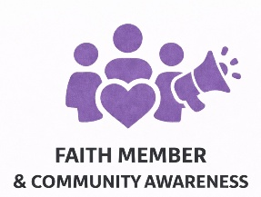 | 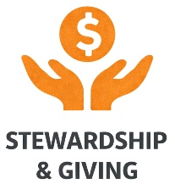 | 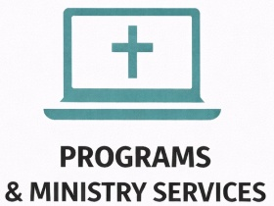 | 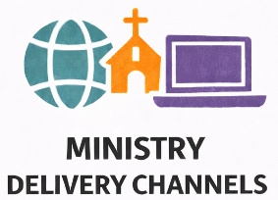

by RE Casper, Marketing Convergence Solutions
www.convergencestrategies.com
www.marketingconvergencesolutions.com
www.ministrymarketingplan.com
info@convergencestrategies.com
Vero Beach, Florida 32967

© 2026, Marketing Convergence Solutions, all rights reserved. No portion of this marketing plan template may be reproduced in any form without written permission from the author, except as permitted by U.S. copyright law. This publication is designed to provide accurate and authoritative information regarding the subject matter covered. We made every effort to ensure the accuracy of the information in this marketing plan template at the time of publication. The writer does not assume and hereby disclaims any liability to any party for any loss, damage, or disruption caused by errors or omissions, whether such errors or omissions result from accident, negligence, or any other cause.
Table of Contents

Page
03 | Introduction
15 | Instructions, Examples, Questions  15 Section I | Organization, Branding, Faith Member Community, Those You Serve  27 Section II | SWOT Analysis (Strengths, Weaknesses, Opportunities, Threats)  47 Section III | Developing Your Ministry Marketing Plan Deliverables: Objectives, Strategies, And Tactics  124 Section IV | Executive Summary  132 Section V | Appendix
132 | Addendum  132 Member Survey Tool  148 Helpful Resources: Faith and Culture Insights, Demographics  154 Demographic Analysis Worksheet  160 About the Author
RD Introduction
This Faith-Based Ministry Marketing Planning Guide and Workbook has been designed to help religious and ministry organizations align their programs and services, communications, and stewardship strategies with their spiritual mission.

Through prayerful reflection and structured planning, your ministry can grow its membership and reach, increase giving, strengthen engagement, and expand its impact for God’s glory.

Each section in the workbook includes guiding questions and examples tailored for faith-driven work. Answer the questions in this fillable workbook or use the online fillable forms with AI to build a spirit-led, measurable ministry marketing plan.

 | Use the online fillable forms  at MinistryMarketingPlan.com  or the fillable fields in this workbook to answer each question. | 

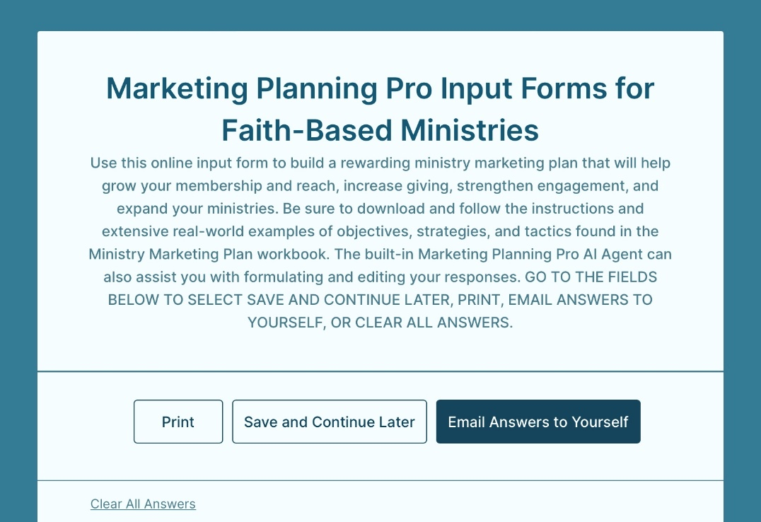
Can You Explain How Your Ministry Performs?

Throughout my years working with businesses, nonprofits, and ministry organizations, one question kept arising: “How do we measure how our programs are truly performing?”

Ministry leaders wanted to see tangible impact, not just activity. They wanted lives changed, communities served, and growth in faith and engagement. They wanted to know: “What fruit is this ministry bearing? How are we advancing God’s work through these efforts?”

Those questions taught me something vital: ministry programs must be more than good intentions and inspired ideas. They must bear measurable, Kingdom-building results. That’s why my teams and I always began with prayerful reflection, clearly defined goals, and measurable outcomes before launching any new initiative.

Tracking results, both spiritual and practical, became our compass. It revealed what was fruitful, what needed refining, and where God was opening new doors. Over time, this discipline transformed how we planned, executed, and evaluated every ministry effort.

The word "marketing" is sometimes viewed negatively in religious contexts because it can evoke commercialism or a focus on numbers over spiritual needs. But without a structured ministry marketing plan grounded in prayer, analysis, and measurable goals, efforts can easily lose direction. A strong plan helps ministries:
- Allocate their time, gifts, and resources wisely
- Expand programs and reach out to those they serve inside and outside of the church
- Strengthen giving and volunteer participation
- Deepen relationships within their faith community and outside of the church walls

That’s why I created this Faith-Based Ministry Marketing Workbook. It offers a seven-step framework filled with practical examples, clear instructions, and AI-powered tools. It’s designed to help you build a Spirit-led, strategic plan that connects your ministry’s mission to measurable outcomes and equips you to share your story with joy, clarity, confidence, and purpose.

The Seven-Step Ministry Marketing Planning Process


₁ | Start by Reviewing This Workbook

Begin your planning journey by prayerfully reviewing this workbook. Each section will help you define your calling, assess your ministry’s strengths, identify your community of faith base, set measurable objectives, and develop actionable tactics.
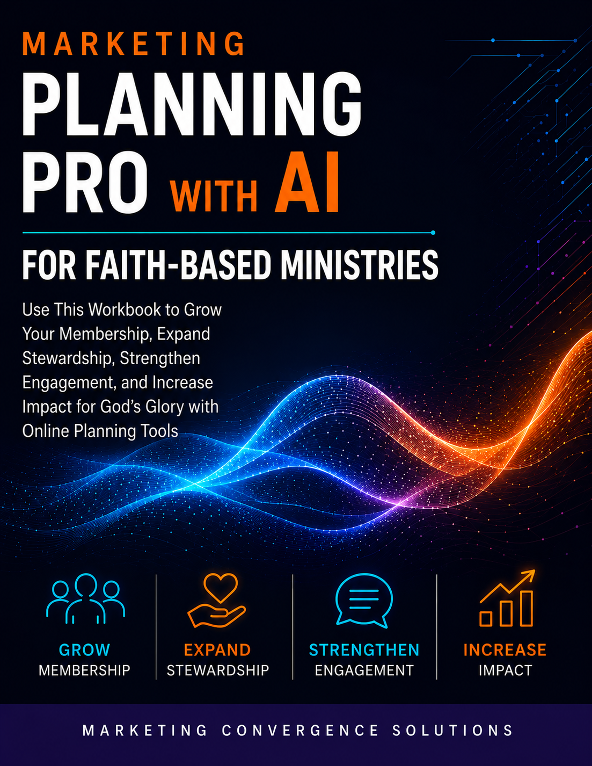

Don’t worry about being perfect. What matters most is clarity, prayerful intention, and commitment to follow-through. Think of this as both a workbook and a playbook. As you and your team complete each part, you’re not just writing a plan; you’re building focused, Spirit-guided strategies to help your ministry reach more people, inspire faithful giving, and make a greater impact for God’s Kingdom.

Use it often. Revisit it regularly. Let it grow with your ministry as you see what’s working and where the Spirit is leading.

Additional strategic planning resources, including AI, are available at:  MinistryMarketingPlan.com | 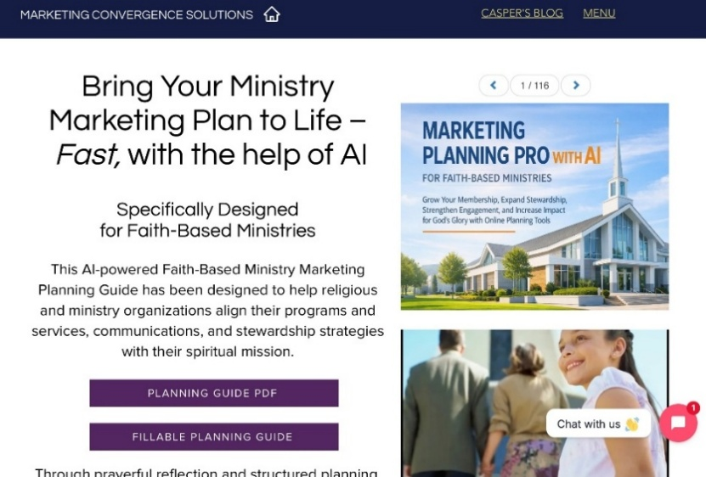
₂ | Select A Planning Team and Facilitator

Gather a small, prayer-centered planning team to develop your ministry marketing plan. Team members can represent various leadership areas of your faith ministry, including:
- Ministry leaders or pastors
- Selected lay ministers
- Head or key members of the church council or governing body
- Outreach leader
- Communications coordinator
- Stewardship or giving director
- Program or mission manager
- Volunteer or service coordinator

Team members need to know their planning contributions are anonymous.

Appoint a Facilitator  to organize and lead planning, run team meetings, encourage participation, and ensure assignments are completed.  Ideally, this person should have ministry-minded values and be trained in planning meeting facilitation. | 
₃ | Complete the Faith Community Survey

Before planning, have the planning team members, all faith community members aged 16 or older, staff, and non-members with connections to the church complete an anonymous survey.

**See the Member Survey Tool
in the ADDENDUM.**

Feel free to edit or add questions to the member survey to fit your faith ministry's unique needs.

Ideally, someone unaffiliated with the faith community should conduct survey analysis and interpretation to maintain objectivity. Use digital apps, such as SurveyMonkey, to distribute, collect, and analyze surveys.  AI can also help you identify meaning and insights in your survey analysis. | 

₄ | Complete Your Demographic Profile

Your faith-based ministry needs deep insights into people and family patterns in the area you serve to understand where your community’s growth is headed.

See the Helpful Resources to compile the most recent demographic statistics for your ministry area. Then complete your Demographic Analysis Worksheet or use the online forms found at:  MinistryMarketingPlan.com  AI can also help determine meaning and insights from your demographic analysis. | 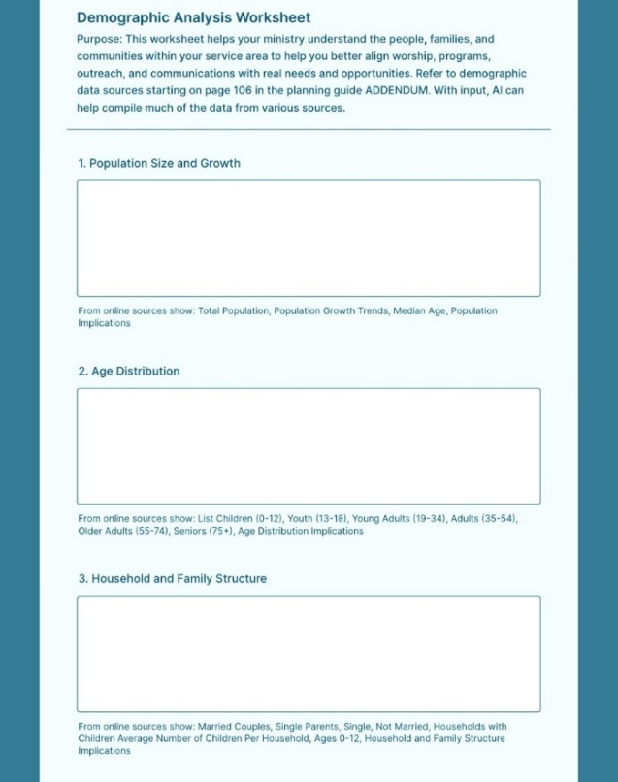

**See the Demographic Analysis Worksheet
in the ADDENDUM.**

₅ | Planning Meeting Organization

Once your team is selected:
- Distribute planning materials:
  - This workbook
  - Results and analysis of the surveys
  - Demographic profile
- Allow members time to reflect and pray over their contributions.

Schedule the Planning Sessions: Set a time for focused, uninterrupted sessions, ideally beginning and ending with prayer for wisdom and unity.  The facilitator should encourage open “free-wheeling” discussions and seriously consider all ideas. Emphasize that all ideas are confidential. | 

₆ | Facilitate Effective Planning Sessions

The appointed facilitator should lead spirit-filled, productive planning sessions:
- Start by having each team member tell the others who they are and what they do for the ministry.
- Ask each team member to describe what they think are impediments to success with the planning. List them on a whiteboard or on a large notepad taped to the wall. Refer to the list often during the planning sessions.
- Ask guided questions for each section and encourage open dialogue.
- Use whiteboards, easels with large notepads, or shared screens to chart and visualize discussion ideas.
- Keep the atmosphere uplifting and collaborative. Include breaks for reflection, prayer, and fellowship.
- Appoint an individual to record key ideas and insights faithfully.
- The facilitator should follow this planning meeting outline:
  - Welcome and planning discussion rules
  - Team member introductions
  - Impediments to success discussions
  - Member surveys and community demographics analysis discussions
  - Review and discuss Organization, Branding, Faith Member Community, Those You Serve questions (Section I)
  - Strengths, Weaknesses, Opportunities, Threats (Section II) discussions:
    - Faith Member and Community Awareness
    - Stewardship and Giving
    - Programs and Ministry Services
    - Ministry Delivery Channels
  - Objectives, Strategies, Tactics (Section III) discussions:
    - Faith Member and Community Awareness
    - Stewardship and Giving
    - Programs and Ministry Services
    - Ministry Delivery Channels
  - Next steps in writing the Ministry Marketing Plan, Executive Summary, and Appendix
₇ | Write the Final Ministry Marketing Plan, Executive Summary, and Appendix

Using the team’s insights from the planning sessions and the Holy Spirit’s guidance, complete your Ministry Marketing Plan, Executive Summary, and Appendix by utilizing the Marketing Planning Input Forms for Faith-Based Ministries in this workbook or online at MinistryMarketingPlan.com.

With online forms, the built-in Marketing Planning Pro AI Agent can assist you with formulating and editing your responses. You can select Save and Continue for later input and editing, print your forms, email your answers to yourself, or clear all answers.

Optionally, you can have team members write the plan. Assign sections based on each team member's strengths. For example, have communications specialists handle Faith Member and Community Awareness, and have finance members focus on Stewardship and Giving.

Resist the temptation to jump straight to tactics without first analyzing and discovering the underlying strategic issues holding you back in each of these areas:

Lean on AI to Strengthen Your Planning

AI tools such as our Marketing Planning Pro AI Assist, ChatGPT, Copilot, Gemini, and Claude can be powerful partners in the planning process. They can help you translate your objectives and strategies into practical, faith-centered tactics, from stewardship campaigns and messaging to social media, content creation, and faith community engagement. AI is not a replacement for discernment. It’s a tool that can free up your time, allowing you to focus more deeply on people, purpose, and prayer.

How AI Can Support Your Ministry Marketing Planning

Step | AI Contribution
Surveys and questionnaires | Suggest questions and wording, perform in-depth analysis, and recommend implications.
Demographic Profiles | Recommend resources, compile the data, and help provide analysis, insights, and implications.
Predictive Analysis | Use AI-assisted regression analysis to better understand how variable actions relate to better outcomes (such as stewardship)
Objectives | Help clarify measurable goals rooted in your ministry's mission.
Strategies | Ensure that tactics match your community of faith, message, and outreach vision.
Tactics | Generate ideas for programs, stewardship, outreach, events, and content.
Content | Draft social posts, email messages, website copy, and visuals that fit your ministry’s tone and tailor communications for specific purposes and outreach segments.
Optimize performance | Analyze engagement data to recommend improvements and track impact.
Executive overview | Summarize the ministry marketing plan to provide a high-level overview.
How Faith and Artificial Intelligence Intersect

 | Artificial Intelligence (AI) is enhancing how people communicate, learn, work, and interact with the world. As these technologies become increasingly integrated into society, churches and faith-based organizations are exploring how AI can support ministry while carefully considering its ethical and theological implications.
Most religious institutions view AI as a powerful tool rather than a source of spiritual authority. AI can enhance planning, outreach, administration, education, and communications, helping ministries operate more effectively. At the same time, faith communities emphasize that AI can never replace the uniquely human qualities of empathy, compassion, wisdom, spiritual discernment, and personal relationships that are essential to ministry.

The rapid growth of AI also raises important questions about privacy, bias, economic well-being, power, and even what it means to be human. According to the Cape Town Commitment from the Lausanne Congress, emerging technologies such as AI have “deep implications for the Church” and require thoughtful Christian engagement. Likewise, AI and Faith encourage people of faith to bring ethical and spiritual perspectives to the ongoing conversation surrounding these technologies. (www.lausanne.org)

While AI can be used in ways that distort truth or diminish human dignity, many Christians see it as part of humanity’s God-given capacity for creativity and innovation. The challenge is to guide its development and use in ways that promote justice, stewardship, truth, and the common good.

Learn more about the implications of Faith and AI at www.aiandfaith.org .
Instructions, Examples, Questions

 | Use the online fillable forms  at MinistryMarketingPlan.com  or the fillable fields in this workbook to answer each question.

Section I | Organization, Branding, Faith Member Community, Those You Serve

Analyze your faith community's background and history to understand where you are today and how you arrived there.
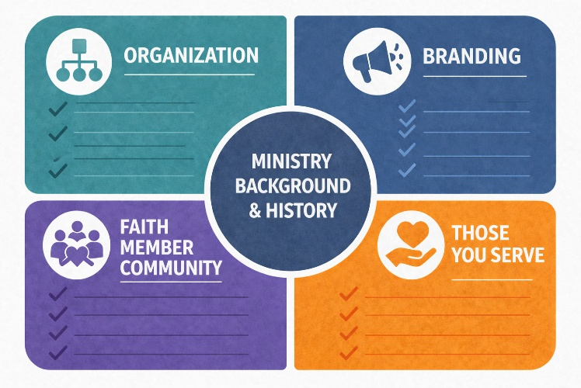

This section helps clarify your church’s position within the community by defining its mission and vision while also examining the demographics of the people groups you hope to reach.

Together, these insights provide a foundation for planning future ministry and outreach efforts.

Question 1 |  Organization Description and Branding  Provide an overview of your faith-based ministry, including:  - Legal name  - Founding year  - Leadership  - Core mission focus  Describe your brand identity and what values define your ministry, how you wish to be perceived, and the tone or imagery that represents your mission.  - What does your brand identity stand for?  - What is your “value proposition” (unique benefits and differentiators you offer) to your community of faith, members, and potential members?  - What visual elements (logo, colors, style) represent the brand?  - What tone of voice do you use in communication? | 

Question 2 |
Faith-Based Ministry History
Summarize key milestones:
- How your ministry started
- Growth of programs over the years
- Community impact over time

Question 3 |
Core Values and Culture
- List 3 to 6 guiding principles that shape your ministry’s behavior and decision-making.
- Explain how these values influence staff, ministry team members, or volunteers, and your faith community.
- Describe how they support your mission.

Question 4 |
Mission Statement
Write a mission statement that reflects your ministry’s calling and purpose. How does your mission reflect God’s work through your organization?

Examples
Saddleback Church Mission Statement
We exist to urgently lead people to say yes to Jesus and his purposes for their lives. The Mission Team promotes this by creating opportunities for people to make a difference and impact the world by sharing about Christ, serving others in need, and shepherding volunteers.

St. Martin’s Episcopal Church, Houston, Texas Mission Statement
To bring, by the power of the Holy Spirit, as many people as possible to know, love, and serve God as revealed through Jesus Christ; and to be transformed into spiritually renewed disciples of Jesus who know, love, and serve one another and the world.

United Methodist Church, Leawood, Kansas Mission Statement
Embracing all of God's children from generation to generation by welcoming all who seek the Gospel. We will nurture all believers on their journey with Christ and be a congregation that serves a world in need.

World Vision Mission Statement
World Vision is an international partnership of Christians whose mission is to follow our Lord and Savior Jesus Christ in working with the poor and oppressed to promote human transformation, seek justice, and bear witness to the good news of the Kingdom of God.

Question 5 |
Vision Statement
Write a statement of your church's vision for serving your congregation and the community.

It should describe what your ministry aspires to become or achieve in the long term. It should inspire your staff, faith community, and those you serve outside of the church.

Examples
Saddleback Church Vision Statement
We want to be a place of family, community, and hope. We welcome the community with open arms. We want to train an army of people who are passionate about living out God's purpose for their lives. Then give that army an outlet to share the love of Christ through outreach and missions.

United Methodist Church, Leawood, Kansas Vision Statement
To be a community of people experiencing God's love and grace through Jesus Christ and seeking to make the message of God's transforming love real for us and others.

World Vision
Our vision for every child is life in all its fullness. Our prayer for every heart is the will to make it so.

*Vision Statement inspired by and based on John 10:10: “I have come that you might have life, life in all its fullness.”

Question 6 |
Community Position
- Explain how your ministry is positioned within your mission area.
- Highlight your distinct approach, trusted reputation, or innovative service model.

Question 7 |
Faith Community Segments
Define the primary groups within your faith community.
Describe their motivations and engagement behaviors that drive their involvement.
- Congregation members
- Ministry team members
- Paid staff
- Volunteers
- Church council members
- Lay leadership

Question 8 |
Those Served Outside
of the Faith Community
- Identify those you serve or minister to outside of the faith community.
- Describe their challenges and how your ministries address their needs.

Question 9 |
Geographic Reach
Describe your current and planned service areas, including delivery channels to those you serve or minister to (in-person, virtual, hybrid).
- Local
- Regional
- National
- International

Question 10 | Demographic Analysis
If you have completed your Demographic Analysis Worksheet in the ADDENDUM, recap your top demographic insights for your service area here. AI can be especially helpful here for interpreting and summarizing your demographic analysis.

Question 11 |
Ministries Similar
to Yours
Describe
- What are their strengths and weaknesses?
- How are they positioned in their community?
- What makes your ministry different or more effective in reaching its faith community?
- What makes your ministry different or more effective in reaching those you serve or minister to outside of the church?

Section II | SWOT Analysis (Strengths, Weaknesses, Opportunities, Threats)

A SWOT analysis identifies your ministry’s Strengths, Weaknesses, Opportunities, and Threats. It helps align your strategies with internal capabilities and external conditions.  Instructions for Strengths  Ask: What does the ministry do well, and what gives it an advantage in reaching out to potential new members? | 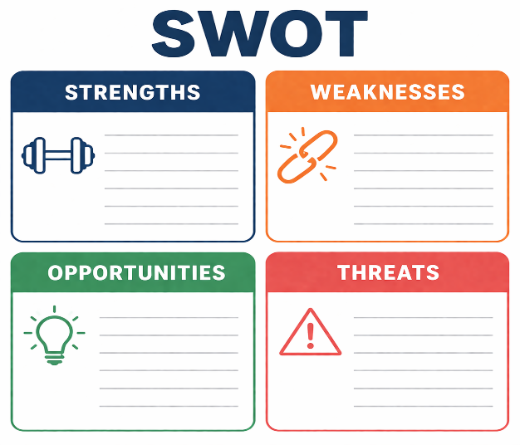
Instructions for Weaknesses
Ask: What areas does your ministry fail to deliver on promises and underperform in? Be honest. Identifying weaknesses is critical for planning improvements in growth and outreach.
Instructions for Opportunities
Ask: What trends, gaps, or changes can your ministry
leverage? Look at both macro and category-specific trends.
Instructions for Threats
Ask: What external forces could negatively impact your ministry in each of these areas? Monitor your environment regularly to identify early warning signs.
Answer Questions 12 through 27 to complete a SWOT Analysis (Strengths, Weaknesses, Opportunities, and Threats) for each area.

**Reference your survey results and demographic analysis for additional directions in completing your SWOT analysis.**

Question 12 |
Strengths for Faith Member and Community Awareness
Examples
- Consistent communication through newsletters, website, and social media posts
- Strong and positive sense of engagement and enthusiasm exhibited by pastors, church leadership, and staff
- Inspiring preaching and teaching that clearly communicates the ministry’s faith and mission
- Positive reputation in the community for service, hospitality, or spiritual leadership
- Engaging testimonies and stories that highlight God’s work in people’s lives
- Dedicated communications team that manages messaging effectively
- High-quality worship streaming or sermon recordings that reach remote or homebound members
- Good signage and welcoming visuals
Question 13 |
Weaknesses for Faith Member and Community Awareness
Examples
- Inconsistent messaging between ministries or communication channels
- Website is outdated, dull, not inspiring, often not updated, difficult to navigate, or not mobile-friendly
- Information overload during services or newsletters, causing people to miss what matters
- Brand identity unclear or unrecognizable (logo, colors, tone not standardized)
- Limited engagement on social media, outdated content, or no posting schedule
- Lack of a communications “owner” or team
- Unclear pathways for visitors to learn about programs, next steps, or how to get involved
- Poor documentation or promotion of ministry impact, mission stories, or community service

Question 14 |
Opportunities for Faith Member and Community Awareness
Examples
- Growing community population, new neighborhoods, and new families seeking spiritual belonging
- Increased digital engagement trends (people looking for online sermons, podcasts, devotionals)
- Development of stronger partnerships with other churches, nonprofits, schools, or civic groups.
- New communications tools or technologies that streamline updates or increase reach
- Seasonal opportunities (Advent, Easter, back-to-school, missions' month) that generate natural momentum
- Younger generations are eager for authenticity and ministries with a clear purpose and transparency
- Interest in live streaming, online prayer groups, or virtual classes that expand reach
Question 15 |
Threats to Faith Member
and Community Awareness
Examples
- Community skepticism toward religious institutions or negative cultural perceptions
- Competing messages from secular nonprofits, local events, and digital distractions
- Noise and information overload in people’s lives make it harder to break through
- Technology barriers for older members or those without consistent internet access
- Negative reviews or misinformation online can influence public perception
- Local crises, political tensions, or community polarization affecting how communication is received
- High expectations for digital communication standards compared to other organizations
- Negative online reviews
Question 16 |
Strengths for Stewardship and Giving
Examples
- Biblical teaching on generosity is strong and consistent throughout the year
- Regular giving increases year after year
- Ministry leaders set an example for faithful giving
- Increasing number of tithing members and increases in average monetary amounts per tithing member
- Faithful core of regular givers who believe deeply in the ministry’s mission
- Transparent financial reporting that builds trust with members and donors
- Effective online or digital giving tools are already in place
- Strong testimonies or stories showing how giving impacts ministry and mission
- Healthy relationships between staff, finance committees, and the congregation
- Reliable systems and processes for counting, reporting, and acknowledging gifts
- Dedicated volunteers or staff who champion stewardship initiatives

Question 17 |
Weaknesses for Stewardship and Giving
Examples
- Giving is concentrated among a small percentage of members
- Low participation from newer or younger families
- Lack of year-round teaching about stewardship and spiritual generosity (only annual appeals)
- No intentional follow-up with new givers or lapsed givers
- Limited communication about how giving supports ministries, missions, and outreach
- Inefficient systems for tracking gifts, engagement, or donor insights
- Website or giving tools are outdated, confusing, or underused
- Poor visibility of financial impact, leading to misunderstandings or a lack of enthusiasm
- Stewardship messages feel transactional instead of spiritual or mission-driven

Question 18 |
Opportunities for Stewardship and Giving
Examples
- Growing community population or new families visiting the church
- Desire among younger generations for causes that show transparency and measurable impact
- New digital tools that simplify recurring giving, mobile giving, and online pledge management
- Partnerships with local organizations that highlight community impact
- Testimonies or stories from missionaries, ministries, or transformed lives ready to be shared
- New communication channels (videos, social media, livestream) to tell stewardship stories
- Seasonal energy around Lent, Easter, Thanksgiving, and Christmas giving
- Generosity trends in philanthropy, grant-making, or donor-advised funds
- Interest in legacy giving or estate planning among mature members

Question 19 |
Threats to Stewardship
and Giving
Examples
- Economic downturns, inflation, or financial stress impacting families’ ability to give
- Increasing competition for charitable donations from other nonprofits, charities, and online causes
- Cultural shifts toward secularism, reducing traditional church giving habits
- Decline in physical attendance, meaning fewer in-person offering opportunities
- Aging donor base without enough younger givers stepping in
- Financial mistrust in the broader culture, requiring greater transparency
- Unexpected facility costs that strain the ministry budget
- Loss of key staff or volunteer leaders who champion stewardship
.

Question 20 |
Strengths for Programs
and Ministry Services
Examples
- Strong participation in core programs such as worship, small groups, Bible studies, and children’s ministries
- Experienced and spiritually mature leaders guiding programs with wisdom and consistency
- Programs that clearly reflect the church’s mission and values (e.g., discipleship, outreach, community service)
- High-quality worship experiences (music, preaching, teaching, hospitality)
- Long-standing programs with proven community impact (food pantry, mission partnerships, youth mentorship)
- Well-developed children’s and youth ministries with strong volunteer support
- Positive feedback from members about specific ministries or initiatives
- Church facilities that support diverse programming (gym, classrooms, multipurpose spaces)
- Strong culture of service among members who volunteer consistently

Question 21 |
Weaknesses for Programs and Ministry Services
Examples
- Programs lack clear goals, measurable outcomes, or a connection to the church’s mission
- Lack of visible support for programs from senior leadership and pastors
- Volunteer shortages leading to fatigue, burnout, or inconsistent program delivery
- Gaps in ministries for certain age groups or spiritual needs (young adults, seniors, new believers)
- Low participation in certain programs, events, or service opportunities
- Programs that feel outdated, irrelevant, or no longer serving their intended purpose
- Overcrowded ministry calendar, creating confusion or competition between programs
- Lack of diversity in program offerings (limited discipleship, outreach, fellowship options)
- Facility limitations hinder growth or accessibility for certain groups
- Limited pastoral care coverage during hospitalizations or crises
Question 22 |
Opportunities for Programs and Ministry Services
Examples
- Growing community needs (e.g., childcare, emotional support, financial coaching, senior care).
- Expansion of digital ministries (online Bible studies, livestream worship, virtual prayer groups)
- New partnerships with schools, nonprofits, or local service organizations
- Demographic changes that reveal new ministry opportunities (young families moving into the area, immigrants, retirees)
- Interest from members in new ministry ideas (sports ministry, recovery groups, counseling services)
- Availability of grants for community outreach, education, or health programs
- New facility potential, such as land, buildings, or repurposing existing spaces
- Opportunities to revive or modernize traditional ministries with updated formats or tools
- Technology and digital tools are making it easier to track participation, share content, or offer online services
Question 23 |
Threats to Programs
and Ministry Services
Examples
- Economic pressures affecting families’ ability to participate or volunteer
- Competing demands on people’s time (sports, school activities, work commitments)
- Declining church attendance trends in the broader culture
- Rising facility costs (utilities, repairs, insurance) that limit program expansion
- Regulatory or licensing requirements for childcare, counseling, or community programs
- Increased competition with other local churches or nonprofits offering similar services
- Community skepticism or misunderstandings about faith-based ministries
- Generational shifts, e.g., younger people may prefer new formats, styles, or digital-first engagement
- Unexpected events such as pandemics, natural disasters, or leadership transitions
- Volunteer burnout or turnover, making programs unstable or inconsistent

Question 24 |
Strengths for Ministry Delivery Channels
Examples
Worship
- Strong preaching and biblical teaching that connects and engages
- Consistent worship attendance and positive feedback from members
- High-quality livestream or recorded services
Music Ministry
- Skilled musicians, choirs, or praise teams provide a high standard of performance musicianship
- A wide range of musical styles that appeal to multiple generations of members
Faith Formation
- Well-developed children’s ministry programs
- Engaged youth ministry with mission trips, service projects, and discipleship groups
- Robust adult discipleship options
- Strong pastoral care team offering prayer, counseling, visitation, and support
Facilities
- Flexible and updated facilities
- Welcoming environment
- A “beacon of light” to the community
Question 25 |
Weaknesses for Ministry Delivery Channels
Examples
Worship
- Attendance fluctuation or decline
- Limited worship diversity
- Worship services feel “routine” or disconnected from daily life
- Technology or AV issues that disrupt online or in-person worship
Music Ministry
- Difficulty recruiting or retaining choir/band members
- Reliance on a small group of overworked volunteers
- Music that detracts from rather than reinforces the worship experience
Faith Formation
- Gaps in discipleship offerings for certain age groups
- Lack of structured curriculum or long-term discipleship pathways
- Challenges in following up with visitors, new families, or lapsed members
Facilities
- Aging infrastructure with poor lighting and inadequate sound systems
- Insufficient classroom or worship space for growth
Question 26 |
Opportunities for Ministry Delivery Channels
Examples
Worship
- Growing community or new neighborhoods seeking faith connection
- Rising interest in online worship, podcasts, or digital devotionals
Music Ministry
- Supplementing church musicians with a few paid professionals
- Special concerts or worship nights that attract visitors
- Use of technology (YouTube, Facebook) to livestream concerts) to extend reach
Faith Formation
- Community needs for pre-K programs, parenting classes, tutoring, or ESL (English as a Second Language) support
- Mission partnerships with local nonprofits or international ministries
- Starting new campus ministries, satellite worship locations, or micro-church/home groups
Facilities
- Repurposing existing spaces for community events or rental revenue
- Improving physical attractiveness and visibility to the community
Question 27 |
Threats to Ministry Delivery Channels
Examples
Worship
- Broader cultural decline in church attendance
- Competition from online content that replaces in-person worship
- Community skepticism toward organized religion
Music Ministry
- Budget cuts are limiting music investments
- Competition for people’s time from school, sports, and work
- Music performance styles and music not aligned with faith members' preferences
Faith Formation
- Families are overwhelmed by busy schedules
- Reduced commitment to programs
- Changing demographics affecting the long-term sustainability of youth programs
Facilities
- Rising facility and utility costs
- City zoning or regulatory barriers for expansions
- Lack of space to grow and expand physical footprint
Prepare Your Giving and Membership Goals
for Current Year, Year 1, Year 2, and Year 3

Giving and membership reflect the health and stability of the faith-based organization. When setting giving and membership goals, planners must balance ambition with realism and ensure that these goals align with broader strategies. Below are the key considerations to guide the goal-setting process: | 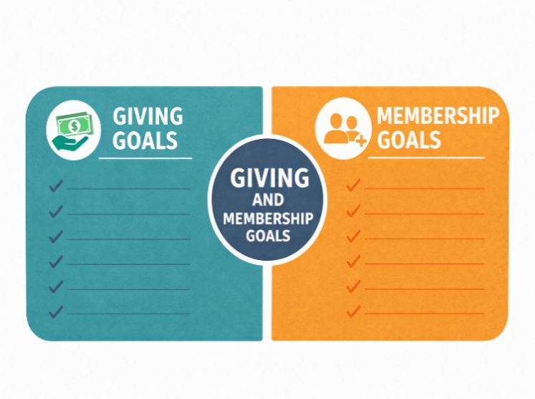
Use Historical Data
- Analyze past performance.
- Identify seasonality, trends, and patterns to create realistic baselines.

Make Goals SMART
- Specific – Clearly define what you want to achieve
- Measurable – Use concrete metrics
- Achievable – Stretch, but within reach given your resources
- Relevant – Tied directly to your organization’s priorities
- Time-based – Set deadlines

Account for Market Conditions
- Consider economic trends, consumer confidence, and other external factors.

Plan for Monitoring and Adjustment
- Set checkpoints (e.g., monthly reviews) to monitor progress.
- Be ready to refine goals if outside threats or influences adversely affect them.

Question 28 |
Develop Giving Goals
for Current Year, Year 1, Year 2, and Year 3
Current Year:

Year One:

Year Two:

Year Three:

Question 29 |
Develop Membership Goals
for Current Year, Year 1, Year 2, and Year 3
Current Year:

Year One:

Year Two:

Year Three:

Section III | Developing Your Ministry Marketing Plan Deliverables: Objectives, Strategies, and Tactics

Develop your ministry marketing plan deliverables: the objectives, strategies, and tactics for each of the four areas of engagement. Refer to your survey results and SWOT analysis (Strengths, Weaknesses, Opportunities, and Threats) for direction.  Definitions  Objectives (What will you achieve?)  Objectives should align with the overall marketing plan's goals and use strategies that serve as performance benchmarks. | 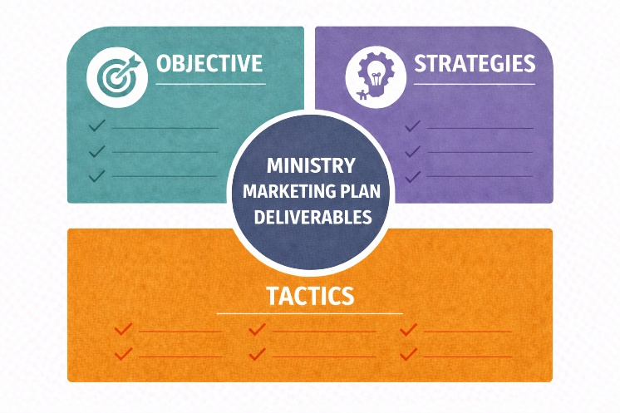
 | 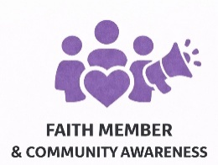 | 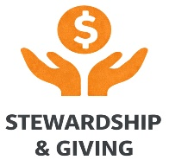
 | 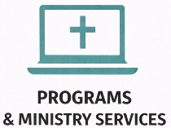 | 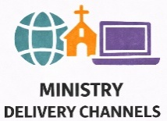
Ensure Objectives and Strategies are SMART:
Specific Measurable (KPIs, Key Performance Indicators)
Achievable Relevant Time-Based

Strategies (How will you achieve it)
Strategies outline how you will achieve each objective. They should align with the strengths, weaknesses, opportunities, and threats the planning team considers important to address.

Key Performance Indicators (KPIs) (How will you measure it)
KPIs provide valuable insights into how well the ministry's marketing strategy and tactics are progressing toward achieving the objective.

Examples of KPIs can include:
- 12% Increase in membership
- 15% Increase in Average Worship Attendance (AWA)
- 20% Increase in giving

Target Audiences (Who we are trying to reach)
- Current faith community members and program users
- Prospective faith community members
- Current members who tithe or give regularly (renewals and lapsed supporters)
- Volunteers to run or participate in programs and services

Tactics (What will you do, step-by-step)
Tactics provide specific actions to deliver the results for the objective and strategy. Each must include:
- Implementation details
- Assigned responsibilities
- Timing and budget allocations





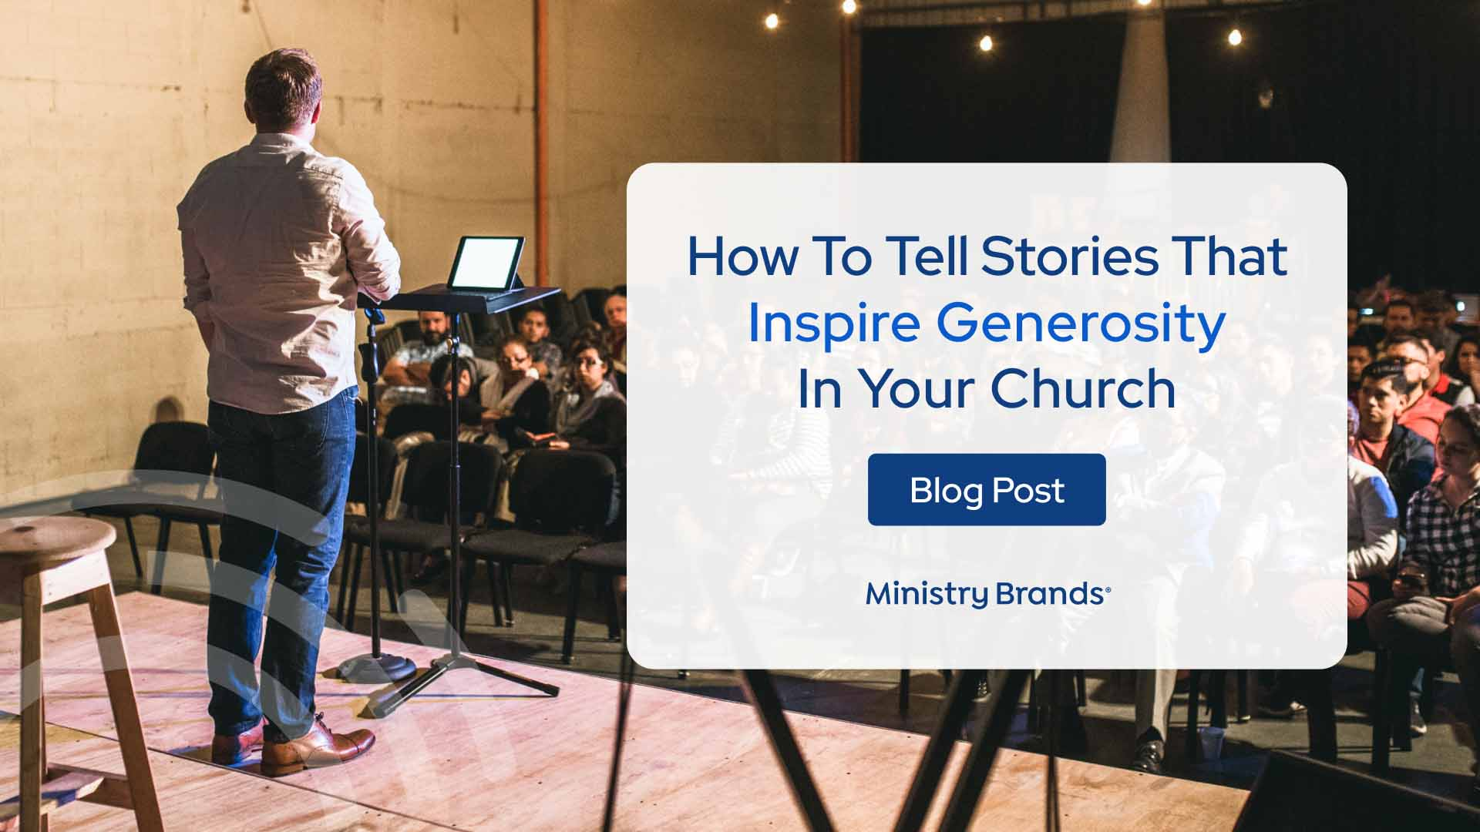
 | Faith Member and Community Awareness  Examples

Faith Member and Community Awareness initiatives can help your ministry reach and engage with your congregation and community by sharing stories of faith, service, transformation, and inspiring involvement. |  | 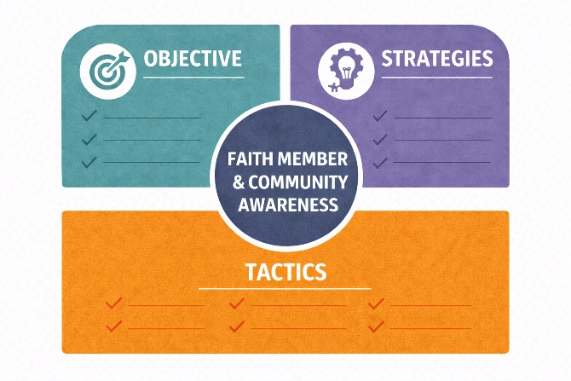
Faith Member and Community Awareness Objective
(What will you achieve)
Strengthen awareness, engagement, and connection to the church’s mission by increasing overall community awareness by 20% (measured by website traffic and social media reach).

Social Media Engagement Plan for a Faith-Based Ministry  - Strategy  - KPIs  - Target Audience  - Tactics  Social Media Engagement Plan for a Faith-Based Ministry  - Strategy  - KPIs  - Target Audience  - Tactics  (continued)  Social Media Engagement Plan for a Faith-Based Ministry  - Strategy  - KPIs  - Target Audience  - Tactics  (continued)  Social Media Engagement Plan for a Faith-Based Ministry  - Strategy  - KPIs  - Target Audience  - Tactics  (continued) | Strategy (How will you achieve it)  Develop an intentional, story-driven social media ministry that blends inspiration, education, and invitation to connect people to Christ, community, and causes through authentic digital engagement.  This strategy emphasizes:  - Using storytelling to share testimonies, ministry updates, and faith lessons  - Aligning content with church calendar seasons (Lent, Advent, Easter, etc.)  - Creating visual, interactive content that encourages dialogue, not just information-sharing  - Coordinating social media with other communication channels (website, newsletters, live worship, community events)  Key Performance Indicators (KPIs) (How will you measure it)  - 25% increase in total engagement (likes, shares, comments, saves)  - 20% growth in followers across key platforms (Facebook, Instagram, YouTube)  - 15% increase in event participation or online worship attendance originating from social media  - Consistent three posts per week per platform with a minimum engagement rate of 5%  Target Audience (Who we are trying to reach)  - Younger prospective faith community members (seekers)  - Current faith community members and program users frequently engaged with social media  Tactics (What will you do, step-by-step)  1. Planning and Organization  - Appoint a Social Media Ministry Team composed of staff, volunteers, and digital-savvy members.  - Identify key platforms based on audience demographics, e.g., Facebook (adults/families), Instagram (young adults), YouTube (sermons/testimonies).  - Create a content calendar for six months with weekly faith themes (e.g., Hope Mondays, Testimony Thursdays, Faith Fridays).  - Establish brand guidelines for consistent tone, imagery, and logo use reflecting ministry values and mission.  - Responsibilities: TBD  - Timing: TBD  - Budget: TBD  2. Faith-Centered Content Creation  Post daily scripture reflections with engaging visuals and short devotional insights.  - Share weekly testimonies or “faith stories” from members, volunteers, or missionaries showing God at work in everyday life.  - Highlight ministry impact stories (e.g., food drives, mission trips, youth service projects) to connect giving and faith in action.  - Create short video devotionals or pastor’s messages (1–3 minutes) to post on Facebook, Instagram, YouTube.  - Include prayer requests and praise reports to invite two-way interaction and spiritual engagement.  - Responsibilities: TBD  - Timing: TBD  - Budget: TBD  3. Engagement and Community Interaction  - Encourage followers to comment, share, and tag friends in posts about prayer, gratitude, or outreach opportunities.  - Assign a volunteer or team member to monitor comments and messages daily and respond with care and encouragement.  - Create interactive posts such as polls (“What are you thankful for today?”) or quizzes (“Which Psalm inspires you most this week?”).  - Host monthly live-streamed QandA sessions or “Faith Talks” with pastors or ministry leaders where followers can submit questions.  - Celebrate milestones (baptisms, mission completions, anniversaries) through photo albums and thank-you messages.  - Responsibilities: TBD  - Timing: TBD  - Budget: TBD  4. Multimedia and Visual Branding  - Use high-quality photography and video for worship services, events, and community service.  - Brand all images with your ministry logo and a unifying hashtag (e.g., FaithInAction, #TogetherInChrist, #ShineHisLight).  - Add videos of short worship music clips, sermon highlights, and events.  - Responsibilities: TBD  - Timing: TBD  - Budget: TBD  5. Outreach  - Run targeted Facebook or Instagram ads promoting online worship, community programs, or giving opportunities.  - Encourage members to “be digital evangelists,” sharing ministry posts to reach their friends and networks.  - Cross-promote events with other local ministries or schools.  - Include social media links on the website, bulletins, email newsletters, and signage throughout the church.  - Consider “retargeting” likes and clicks with follow-up ads.  - Responsibilities: TBD  - Timing: TBD  - Budget: TBD  6. Evaluation and Continuous Improvement  - Review analytics monthly to track engagement rates, top-performing content, and audience demographics.  - Adjust posting times, formats, and content types based on data insights.  - Survey members and followers quarterly about what inspires them the most online.  - Celebrate social media milestones with the congregation, reinforcing how the online ministry is expanding the church’s reach.  - Responsibilities: TBD  - Timing: TBD  - Budget: TBD  7. Total Budget for all Social Media Tactics
Mobile App Development Plan for a Faith-Based Ministry  - Strategy  - KPIs  - Target Audience  - Tactics  Mobile App Development Plan for a Faith-Based Ministry  - Strategy  - KPIs  - Target Audience  - Tactics  (continued)  Mobile App Development Plan for a Faith-Based Ministry  - Strategy  - KPIs  - Target Audience  - Tactics  (continued)  Mobile App Development Plan for a Faith-Based Ministry  - Strategy  - KPIs  - Target Audience  - Tactics  (continued) | Strategy (How will you achieve it)  Create a user-friendly, spiritually enriching mobile app that connects people to God, to each other, and to the ministry through daily devotionals, prayer support, communication tools, giving options, and event information, turning digital convenience into ongoing spiritual engagement.  This strategy emphasizes:  - Strong spiritual content delivered daily  - Tools that simplify and streamline communication  - Intentional features for discipleship and pastoral care  - Seamless integration with the ministry website and database  - Accessibility for all ages and comfort levels  Key Performance Indicators (KPIs) (How will you measure it)  - App launched by Month nine with all core features active  - At least 50% of active members download the app within 3 months of launch  - 33% increase in daily/weekly engagement (devotional reads, event views, prayer submissions)  - 20% increase in online giving through the app  - 20% increase in participation in events or ministry programs driven by app notifications  Target Audience (Who we are trying to reach)  - Younger prospective faith community members (seekers)  - Current faith community members and program users frequently use mobile apps  Tactics (What will you do, step-by-step)  1. Planning, Research & Team Development  - Form a mobile app ministry team made up of staff, tech volunteers, communications leaders, and ministry members.  - Conduct a needs assessment with members, staff, and community users to identify desired app features.  - Define a clear app mission statement, e.g.:  “To connect our church family daily to God, community, and ministry life through meaningful digital engagement.”  - Create a project timeline, budget, and assign team roles.  - Choose an app development platform or partner (e.g., ChurchCenter, TouchPoint, Subsplash, Tithe.ly, PushPay).  - Responsibilities: TBD  - Timing: TBD  - Budget: TBD  2. Design & Core Features Development  Create a mobile app that meets the communication and spiritual needs of the entire community:  Core Features:  - Daily devotionals (written or video) from pastors and lay leaders  - Prayer request submission with options for public, private, or pastoral-only visibility  - Push notifications for events, needs, urgent prayer, giving appeals, and weather closings  - Mobile giving tools, tithes, offerings, special projects, recurring donations  - Event calendar with RSVP, reminders, and volunteer sign-up forms  - Livestream and sermon library integrated into the app  - Ministry directories (children, youth, music, missions) with contact links  - Volunteer hub for sign-ups and service opportunities  - Bible reading plans or scripture of the day  - Small group finder with meeting times, leaders, and locations  - Pastoral care request forms for hospital visits, counseling, or support  Design Priorities:  - Warm, faith-centered visuals  - Intuitive user interface  - Accessibility features (font size, audio playback, color contrast)  - Consistent branding with the church website  - Responsibilities: TBD  - Timing: TBD  - Budget: TBD  3. Content Creation and Spiritual Integration  - Create a content plan for daily devotionals, weekly pastor messages, and scripture reflections.  - Recruit a team of devotional writers (pastors, ministry staff, lay leaders).  - Build a prayer team dedicated to responding to app-submitted requests.  - Prepare 30–60 days of devotional content ready for launch.  - Create video testimonies and “Welcome to the App” onboarding tutorial.  - Integrate seasonal spiritual content (Lent, Advent, special weeks of prayer).  - Responsibilities: TBD  - Timing: TBD  - Budget: TBD  4. Communication and Launch Campaign  - Promote the app through worship announcements, newsletters, social media, and the website.  - Use QR codes frequently on bulletins, signage, postcards, and welcome bags.  - Host an App Launch Sunday with live demonstrations.  - Provide volunteers to assist members with downloads and onboarding.  - Encourage staff and ministry leaders to be early adopters and app ambassadors.  - Offer incentives such as a “Download the App” challenge or a devotional series available only through the app.  - Responsibilities: TBD  - Timing: TBD  - Budget: TBD  5. Ongoing Engagement and Content Refresh  - Schedule consistent updates: new devotionals, event banners, and sermon uploads.  - Use analytics to track which features are being used and adjust the content accordingly.  - Create monthly spiritual growth themes with coordinated app content (e.g., “Prayer Month,” “Serve Together Month”).  - Encourage ministries (youth, choir, missions, small groups) to submit content weekly.  - Send push notifications strategically, encouraging but not overwhelming.  - Introduce new features quarterly (polls, chat groups, Bible studies, volunteer badges).  - Responsibilities: TBD  - Timing: TBD  - Budget: TBD  6. Evaluation and Continuous Improvement  - Review engagement analytics monthly (downloads, active users, activity rates).  - Survey users 60–90 days after launch.  - Adjust navigation, content style, and notification frequency based on data.  - Evaluate impact on giving, event attendance, and engagement.  - Prepare a report summarizing app-driven ministry impact.  - Responsibilities: TBD  - Timing: TBD  - Budget: TBD  7. Total Budget for all Mobile App Development Tactics
Faith-Based Ministry Website Revitalization or Development

Consider using a template such as this to format your strategies and tactics.

STRATEGY  for Website Revitalization  or Development (How will you achieve it) | Develop a Christ-centered, information-rich, and visually engaging website that unites communication across all ministry areas, simplifies access to key information and services, and reflects the ministry’s identity, mission, and community outreach.  This strategy emphasizes:  - Designing for clarity, warmth, and accessibility  - Serving multiple audiences: members, staff, seekers, donors, and media  - Integrating digital tools for engagement, giving, and communication  - Ensuring continuous updates to keep content fresh, relevant, and mission-aligned
KPIs (Key Performance Indicators)  for Website Revitalization  or Development  (How will you measure it) | - Website launched by Month six with all core pages and functionality live  - 20% increase in online engagement (page visits, downloads, prayer requests, event registrations) within three months of launch  - 15% increase in new visitor inquiries or service attendance originating from the website  - 50% of active members use online tools (donations, forms, or event registrations) regularly  - Average visitor session time exceeds two minutes, indicating meaningful engagement
TARGET AUDIENCE  for Website Revitalization  or Development (Who we are trying to reach) | - Church members  - Church attendees and prospective members  - Staff  - Seekers
TACTICS for Website Revitalization or Development (What will you do, step-by-step)
1. Planning and Preparation
- Form a Website Development Team including ministry leaders, communications staff, IT volunteers, and representatives of key audiences (e.g., youth, missions, worship).
- Conduct a needs assessment to identify what each group (members, staff, visitors) needs most from the website (e.g., online giving, sermon access, event calendars).
- Develop a website mission statement, for example:
“To extend the ministry of our church online by connecting, informing, and inspiring faith through every click.”
- Define budget, hosting, and maintenance resources for initial design and ongoing updates.
- Research and select a content management system (CMS) (e.g., WordPress, Squarespace, Wix) that allows staff or volunteers to update content easily.

Responsibilities Teams | Timing | Budget
Ministry leaders / Communications lead / IT / Outside agency if needed | Q1 | $5,000
2. Website Design and Structure
Create a user-friendly sitemap organized by audience:
  - I’m New (introduction, worship times, directions, FAQ)
  - Members (programs, small groups, calendar, volunteer opportunities)
  - Staff and leadership (directory, resources, ministry reports)
  - Community and Outreach (missions, events, service projects)
  - Giving (online donations, pledge forms, endowment info)
  - Media (sermons, podcasts, livestream archive, photo galleries)
  - Contact and prayer requests (easy-to-use form with follow-up notifications)
- Prioritize mobile-first design (over 60% of visitors will access via phone).
- Ensure site adheres to ADA accessibility standards (readable fonts, text contrast, alt text for images).
- Integrate clear calls-to-action (CTAs) on every page, e.g., Join Us Sunday, Submit a Prayer Request, Volunteer Today, Give Online.
- Use consistent visual branding (logo, color palette, tagline) that reflects ministry values.
Responsibilities Teams | Timing | Budget
Communications lead / IT / Outside agency if needed | Q2 | $20,000
3. Content Creation and Storytelling
- Develop faith-centered, welcoming copy that communicates warmth, authenticity, and mission.
- Include testimonies and stories of transformation, and how the ministry impacts lives locally and globally.
- Feature biographies and photos of pastors and ministry leaders to build trust and connection.
- Create engaging media content, sermon videos, short devotionals, blog posts, or podcasts.
- Highlight ministry impact metrics (e.g., “Over 3,000 Meals Served Last Year”) with photos to demonstrate stewardship and outreach.
  - Update events weekly with an interactive calendar linked to registration and reminders.

Responsibilities Teams | Timing | Budget
Ministry leaders / Communications lead / Outside agency if needed | Q2-Q3 | $6,000
4. Interactive Features and Member Tools
- Implement secure online giving and tithing platforms (e.g., PushPay, Tithe.ly).
- Add member portal access for internal documents, volunteer schedules, and meeting notes.
- Include staff login areas for managing updates, communications, and resource sharing.
- Create online forms for prayer requests, visitor sign-ups, volunteer interest, and event RSVPs.
- Integrate live-streaming capabilities for worship services and special events with embedded replays. Use consistent visual branding (logo, color palette, tagline) that reflects ministry values.

Responsibilities Teams | Timing | Budget
Ministry leaders / Communications lead / Outside agency if needed | Q2-Q3 | $6,000
5. Promotion and Launch
- Announce the new website launch during worship services, newsletters, and social media.
- Use email campaigns and printed postcards to invite members and community contacts to explore the new site.
- Include QR codes on signage, bulletins, and flyers that link directly to event registration or donation pages.
- Partner with local ministries or media to share press releases or blog announcements about the launch.
- Offer a “Website Launch Sunday” event featuring a guided demo and live QandA after worship.

Responsibilities Teams | Timing | Budget
Communications lead / Outside agency if needed | Kick off in Q2, then monthly through Q4 | $5,000
6. Ongoing Management and Optimization
- Designate a Website Content Coordinator to oversee monthly updates and ensure accuracy.
- Schedule quarterly reviews with ministry leaders to add new events, remove outdated content, and check all links.
- Use analytics tools (Google Analytics, Squarespace Insights) to monitor visitor trends and engagement.
- Regularly refresh visuals, banners, and photos to reflect current ministry life.
- Encourage members to provide feedback through a “How Can We Improve?” form.

Responsibilities Teams | Timing | Budget
Communications lead / Outside agency if needed | Kick off in Q2, then monthly through Q4 | $5,000
7. Integration and Other Communications
- Link the website with all ministry communication tools, including social media, newsletters, digital signage, and mobile app.
- Ensure consistent messaging, branding, and event synchronization across all platforms.
- Use the website as the central hub for all communications, directing traffic from every channel back to it.

Responsibilities Teams | Timing | Budget
Communications lead / Outside agency if needed | Kick off in Q2, then monthly through Q4 | $2,500
8. Total Budget for Website Development |  | $49,500

 | More Ideas for Faith Members  and Community Awareness

Use these ideas to help guide and expand your development of objectives, strategies, and tactics.

Branding | Effective branding can powerfully advance a faith ministry’s cause by shaping how both members and the broader community see, feel, and connect with its mission. Branding isn’t about marketing polish; it’s about expressing identity, purpose, and promise in a way that reflects Christ’s message and invites others into participation. Faith-based branding isn’t about self-promotion. It’s about mission promotion.  It ensures that every visual, every word, and every interaction point back to the One you serve.  When your ministry’s brand consistently reflects God’s love, integrity, and joy, it becomes a beacon that attracts hearts, strengthens faith, and expands your reach within the congregation and beyond.
Mission and Vision Positioning  Mission and Vision Positioning (continued) | A clearly defined mission and vision do more than decorate a website or brochure. They express the heartbeat of your ministry.  When they are well-crafted, lived out, and consistently communicated, they become spiritual compasses that guide your actions, inspire your congregation, and communicate God’s purpose to the community.  An effective mission and vision serve as beacons for your ministry. They clarify why you exist, unite those who serve, and inspire both your congregation and your community to join in God’s redemptive work.  When your ministry’s mission and vision are lived consistently and not just declared. They transform faith into action and purpose into presence.  “Write the vision; make it plain on tablets, so he may run who reads it.” Habakkuk 2:2
Paid Advertising | Advertising, when guided by mission, can extend your ministry’s reach to those beyond your congregation.  Use local radio, community newspapers, or digital ads, such as geo-targeted Google AdWords and Facebook ads, to highlight stories of impact, such as a family supported through outreach, a youth finding purpose through service, or a community restored through faith.  Every ad should reflect your values and invite participation in God’s ongoing story through your ministry.
Publicity | Press releases, interviews, and media coverage provide powerful opportunities to share your ministry’s testimony with the broader community.  Highlight not just what you do, but why, and focus on God’s work in and through your people. Local news stories about service projects, mission trips, or faith-based events can reach audiences who may never walk through your doors yet are looking for purpose and belonging.  Free press release (PR) distribution services, such as PRLog, OpenPR, and Issuewire, offer cost-effective ways to increase online visibility, improve SEO, and reach broader audiences without charge. These platforms generally provide search engine indexing (Google News), social media integration, and basic distribution to news websites.
Sponsorships  Sponsorships  (continued) | Sponsoring community events, concerts, or service projects allows your ministry to be a visible partner in local life. It demonstrates love in action and your willingness to invest in your neighbors' well-being.  Use sponsorship opportunities to share your mission and invite new supporters to experience your ministry firsthand.
Website  Website  (continued) | Your website serves as your ministry’s digital front door. It’s a place where faith, purpose, and invitation meet.  Make the tone warm and relational, reflecting God’s open invitation to all. Boost web presence with robust SEO strategies.  Use AI agents, such as Chatbots, to enhance the user experience.  Include contact forms with clear next steps for involvement, such as volunteer sign-ups, online giving, prayer requests, and ministry contacts.  Online media can include –  Testimonials: Video or written testimonies are among the most powerful forms of ministry storytelling.  Let members and beneficiaries share how God has changed their lives through your church’s programs, prayer, and community support.  Podcasts: Offer weekly reflections, sermons, or ministry interviews that bring encouragement and teaching to listeners throughout the week. Podcasts create an ongoing spiritual connection and reach new audiences beyond your local community.  Sermons: Archive sermons online for easy access. Add sermon notes, scripture references, and reflection questions so people can revisit the message and share it with others.  Music Recordings: Music ministries can share recordings of worship, choir performances, or praise nights online. Music often touches hearts where words cannot.  Study Library, Lectionary, and Study Bible: Offer downloadable or searchable study materials to help believers deepen their faith.  These tools support personal devotion and small-group study, nurturing discipleship within and beyond the congregation.
Mobile App | A ministry mobile app keeps your faith community connected daily. Include devotionals, prayer requests, giving tools, and notifications for upcoming events or needs.  Apps allow people to engage with your ministry anytime by turning digital convenience into spiritual connection. Popular providers include Tithe.ly, Pushpay, Subsplash.
Calendar  of Activities | An up-to-date, easy-to-navigate calendar keeps your congregation informed and shows your community that your ministry is active and engaged.  Include worship services, Bible studies, mission trips, and volunteer opportunities with links to register or learn more. Integrate storytelling by adding short highlights from past events or quotes from participants.
Email Messaging  Email Messaging  (continued) | Email platforms such as Constant Contact, Mailchimp, Flocknote, and Breeze give ministries a powerful and efficient way to communicate with their congregation, volunteers, donors, and the surrounding community.  Email administrators can track opens and click-throughs to measure engagement levels.  Used well, email becomes a consistent, relational, and mission-driven touchpoint that keeps people informed, encouraged, and engaged. Email messaging platforms help ministries communicate more clearly, consistently, and compassionately by strengthening relationships, increasing participation, and extending spiritual encouragement throughout the week.  When used well, email becomes a digital ministry tool that supports:  - Discipleship  - Hospitality  - Outreach  - Stewardship  - Community connection  “Encourage one another and build each other up.” 1 Thessalonians 5:11
SMS Text Messaging | SMS Text Messaging allows members to opt in to text messaging notifications.  It’s cost-effective and can significantly improve your ministry’s communication with members by providing highly targeted, direct, regularly scheduled, fast, and engaging messages.  Text messaging is available as an add-on service through Constant Contact and other providers.
Social Media  Social Media  (continued) | Facebook Group: Create private or public groups to build community through ongoing discussion, prayer requests, and fellowship. Groups provide a safe space for members to encourage one another, share devotionals, and organize ministry activities that can extend the spirit of the church beyond Sunday.  Facebook: Use Facebook to nurture your faith community throughout the week and not just on Sunday. Share personal testimonies, photos from service projects, scripture reflections, and livestreams of worship. Encourage members to comment, pray for one another, and share posts as a form of digital evangelism.  Instagram: Visual storytelling shines on Instagram. Share inspiring photos, behind-the-scenes moments, and short videos that capture joy, compassion, and connection. Highlight ministry life, such as a child receiving a Bible, a volunteer team at work, or a community meal in progress, to make God’s love visible through imagery.  YouTube: Use YouTube for video reels (long and short), sermons, repurposed content, music performances, and testimonials. Churches should experiment with various video styles, including “lo-fi” video shorts and selfie-style videos that appear spontaneous and unrehearsed, thereby making them more trustworthy.
Live Streaming Worship and Programs | Live-streaming removes barriers of distance and accessibility, allowing your ministry to reach people wherever they are. Because it is often a first impression of your church, it should reflect excellence, clarity, and intentional production quality.  Whether broadcasting a Sunday sermon, a Bible study, or a community outreach event, livestreams let homebound members, travelers, and new seekers fully participate in worship. Create opportunities for engagement by encouraging viewers to submit prayer requests, give online, and connect with others.  Enhance the experience with thoughtful elements such as opening and closing videos, a warm welcome message from your pastor, and QR codes that link directly to your website or next steps. Consider including a short video that highlights your campus and ministries to help viewers feel connected.  Finally, invest in training for videographers and sound technicians to ensure each livestream is delivered professionally, with a clear focus on delivering a high-quality viewing and audio experience for viewers. Consider streaming through free or low-cost services such as YouTube, Vimeo, and Facebook.
Literature  and Personalized Direct Mail  Literature  and Personalized Direct Mail  (continued) | Newsletter (Print and Online): Regular newsletters strengthen connection and transparency. Share ministry updates, financial stewardship, and faith stories that demonstrate how contributions make a real difference.  Worship Bulletins: Beyond logistics, bulletins can include scripture reflections, calls to service, or brief ministry highlights that connect worship to everyday life.  Annual Report: Transform your annual report into a testimony of God’s faithfulness by sharing measurable outcomes alongside stories of spiritual growth.  Magazines (Print and Online): Ministry magazines offer deeper storytelling, such as profiles of volunteers, devotionals, and features on missions or community partners.  Brochures (Mission-Focused): Use brochures for outreach and visitor engagement, focusing on how your ministry’s programs meet physical, emotional, and spiritual needs.  Personalized Direct Mail: Personalized direct mail, including physical letters, postcards, brochures, or packages customized to each recipient, can complement digital channels. It helps organizations strengthen relationships and improve communication that digital-only outreach can’t always achieve.  Church Directory: Church directories, with or without member photos, can be made available in both print and online editions. The key is to keep them up to date.
Logoed Merchandise  and Apparel | Apparel and merchandise aren’t just fundraisers. They’re walking testimonies. When members wear branded shirts or hats with scripture or ministry logos, they spark conversations and visibly represent their faith in the community.
Welcome Bags /  Kits | Welcome kits extend hospitality to new visitors.  Include a welcome letter, a brochure about your ministry’s mission, a small gift (like a devotional or bookmark), and a personal invitation to get involved.

Based on these examples and your own analysis of your needs, write your own Faith Member and Community Awareness objective, strategies, and tactics using these forms or the online forms found at MinistryMarketingPlan.com.

Question 30 | Your Objective for Faith Member and Community Awareness
Question 31 | Your Strategies for Faith Member and Community Awareness
Question 32 | Your KPIs for Faith Member and Community Awareness
Question 33 | Your Target Audience for Faith Member and Community Awareness
Question 34 | Your Tactics for Faith Member and Community Awareness
 |  | Stewardship and Giving  Examples

Stewardship in ministry is more than raising funds. It’s discipleship in action. Faithful giving is an act of worship, gratitude, and partnership in God’s mission.  Effective stewardship ministries cultivate generosity not through pressure, but | 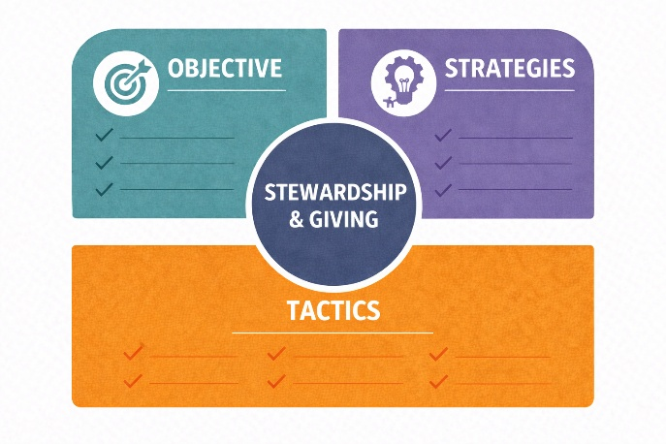
through purpose, transparency, and spiritual invitation. Below are key areas of giving and how each can inspire faith, participation, and long-term sustainability for your ministry.

Stewardship and Giving Objective
(What will you achieve)
Increase financial support (total giving, tithes, and offerings) by 15% year over year, increase participation in recurring/automated giving by 30%, increase the average gift size by 10%, and improve the donor retention rate from 68% to 90% annually.

Annual Giving Plan for a Faith-Based Ministry  - Strategy  - KPIs  - Target Audience  - Tactics  Annual Giving Plan for a Faith-Based Ministry  - Strategy  - KPIs  - Target Audience  - Tactics  (continued)  Annual Giving Plan for a Faith-Based Ministry  - Strategy  - KPIs  - Target Audience  - Tactics  (continued)  Annual Giving Plan for a Faith-Based Ministry  - Strategy  - KPIs  - Target  - Audience  - Tactics  (continued) | Strategy (How will you achieve it)  Develop and implement a year-long, faith-centered stewardship campaign that educates, inspires, and invites members to practice consistent, joyful giving as an act of worship and partnership in ministry.  This strategy emphasizes:  - Teaching biblical principles of stewardship  - Communicating transparency and ministry outcomes  - Creating emotional and spiritual connection through stories of transformation  - Offering convenient, accessible giving options  Key Performance Indicators (KPIs) (How will you measure it)  - 15% increase in total giving compared to the prior year  - 30% increase in recurring monthly givers (electronic or automatic giving)  - Increase average gift size by 10%  - 20% increase in participation in stewardship pledge commitments  - Improved donor retention rate from 68% to 90%  Target Audience (Who we are trying to reach)  - Current faith community members and program users  - Current members who tithe or give regularly (renewals and lapsed supporters)  - Attendees who do not give regularly  Tactics (What will you do, step-by-step)  1. Planning and Preparation  - Form a stewardship leadership team of finance, communication, and ministry leaders by January.  - Review giving data and identify key segments: first-time givers, recurring donors, and lapsed donors.  - Establish a stewardship theme and scripture verse for the year (e.g., “Faithful in Little, Faithful in Much” – Luke 16:10).  - Create a 12-month communication calendar aligned with major seasons (Lent, summer, Thanksgiving, Advent).  - Responsibilities: TBD  - Timing: TBD  - Budget: TBD  2. Education  - Offer a 4-week sermon series on biblical generosity during the spring, emphasizing tithing, gratitude, and faith in action.  - Host a Stewardship Sunday with testimonies from members about how giving has transformed their lives.  - Publish short devotionals or social media posts connecting stewardship to scripture and ministry stories.  - Responsibilities: TBD  - Timing: TBD  - Budget: TBD  3. Community  - Launch a “Giving with Purpose” awareness campaign highlighting specific ministry outcomes funded by giving (missions, outreach, youth programs).  - Send quarterly impact updates showing measurable results: “Your giving helped provide 500 meals this quarter.”  - Include stewardship updates in newsletters, bulletins, and digital platforms with graphs and visual storytelling.  - Feature a video testimony series from ministry leaders and members showing how giving changes lives.  - Responsibilities: TBD  - Timing: TBD  - Budget: TBD  4. Tools and Accessibility  - Introduce or enhance digital giving options (text-to-give, mobile app, QR codes).  - Train staff and volunteers to assist members with setting up recurring online donations.  - Place clear giving prompts and links in worship bulletins, the website and mobile app, signage, and streaming broadcasts.  - Responsibilities: TBD  - Timing: TBD  - Budget: TBD  5. Recognition and Relationship Building  - Send givers notes of gratitude from ministry leaders each quarter.  - Host a "Stewardship Celebrates” in November to honor faithful givers and share the year-end vision.  - Recognize milestone givers (5-year, 10-year supporters) privately or publicly as appropriate.  - Send handwritten thank-you cards to first-time givers within 48 hours of their gift.  - Responsibilities: TBD  - Timing: TBD  - Budget: TBD  6. Year-End Giving Initiative  - Launch a special Advent/Christmas giving campaign (and “Gifts of Hope”) focused on outreach, missions, or facility needs.  - Provide both print and digital materials with clear giving goals and progress updates.  - Share moving stories of ministry impact through email and social media countdowns.  - Offer multiple ways to give, in worship, online, by mail, or through special events.  - Responsibilities: TBD  - Timing: TBD  - Budget: TBD  7. Review and Evaluation  - Conduct a year-end stewardship review meeting to assess KPIs.  - Survey donors to measure satisfaction and identify barriers to giving.  - AI-Assisted Regression Analysis: Use a predictive approach through AI-assisted regression analysis to understand which stewardship activities were most strongly associated with the increases in giving, after accounting for attendance, seasonality, and other factors.  - Use the analysis to investigate whether giving tends to increase following stewardship sermons, whether personal testimony is associated with a stronger response than generic appeals, whether communicating specific ministry outcomes is associated with increased pledges, whether recurring electronic giving produces more stable annual revenue, whether increased attendance predicts subsequent giving, and whether the number or timing of communications matters.  - The analysis could also uncover diminishing returns.  - Example: A church could upload a relatively simple spreadsheet containing several years of monthly stewardship activity and giving results. AI could perform the regression, visualize the relationships, identify statistically meaningful predictors, flag weak or potentially misleading conclusions, and then translate the statistics into plain English for church leadership.  - Share results transparently with the congregation, celebrating growth and setting new goals for the next year.  - Responsibilities: TBD  - Timing: TBD  - Budget: TBD  8. Total Budget for all Annual Giving Plan Tactics

More Ideas for Stewardship
and Giving

Use these ideas to help guide and expand your development of objectives, strategies, and tactics.

Monetary Gifts  to Support Ongoing Operations  Monetary Gifts  to Support Ongoing Operations (continued) | Annual Giving and Tithing Campaign: These campaigns form the foundation of faithful stewardship. Use scripture-based messaging that connects giving with gratitude and trust in God’s provision (e.g., Malachi 3:10, 2 Corinthians 9:7). Include testimonies from members whose lives have been blessed through giving and the ministry’s impact. Use multiple communication channels such as announcements, newsletters, social media, and personal letters to encourage consistent participation.  Year-End Giving: The close of the year offers a natural time for reflection, thanksgiving, and generosity. Encourage members to give from a spirit of gratitude for the blessings of the year. Remind supporters that year-end gifts strengthen the ministry’s ability to serve others and begin the new year with strong momentum. Use personalized messages, special services, and digital giving reminders in November and December.  Endowment Gifts: An endowment gift is a lasting legacy of faith. It’s an offering that keeps giving for generations. Promote endowment opportunities for members who wish to ensure the ministry’s mission endures beyond their lifetime. Communicate clearly how endowment funds are managed, used, and celebrated (e.g., scholarships, ministry support, building upkeep). Offer educational sessions or consultations on estate and planned giving.  Legacy and Planned Giving: Encourage members to include your ministry in their will or estate plans as an expression of lifelong faith. Host workshops on Christian estate planning, emphasizing stewardship as a lasting act of discipleship.  Plate Offerings: Monetary gifts collected during regular worship services can often come from visitors and regular attendees who do not tithe or give consistently.  Digital and Mobile Giving: Offer multiple giving options, including online, text-to-give, or mobile app, making it easy for members to support ministry anytime. Include spiritual messages that remind users that each gift, no matter how small, helps advance God’s Kingdom.
Monetary Gifts  to Support Specific Needs  Monetary Gifts  to Support Specific Needs  (continued) | Memorial Gifts: Memorial gifts honor loved ones while advancing ministry. Encourage families and friends to contribute to the church or ministry in remembrance of a member or community figure. Use these gifts to fund something meaningful, such as a scholarship, garden, or outreach program. Commemorate it with sensitivity and gratitude.  Special Projects Funding: Special projects invite members to participate in tangible acts of generosity. Examples include supporting the music ministry, missionary sponsorships, stained-glass restoration, technology upgrades, and furnishings. Frame each project as an opportunity to invest in God’s work, not just to buy items, but to enable ministry. Share the story of the project’s purpose, the need, and the expected impact.  Building Campaigns: Building or renovation campaigns enable ministries to articulate a long-term vision for growth. Focus communication on how new spaces, whether a sanctuary, fellowship hall, education wing, or memorial garden, will expand opportunities for worship, discipleship, and outreach. Use visual storytelling (architectural renderings, progress videos, dedication ceremonies) to help members feel personally invested in building God’s house.  Mission and Outreach Sponsorships: Allow members to “adopt” specific outreach efforts by supporting missionaries, feeding programs, or international partners. Provide regular updates, photos, and testimonies to show their impact.  Designated Offerings: Provide opportunities to give toward specific ministry areas (e.g., youth, worship, benevolence, missions). This helps connect donors’ passions with tangible impact.  Flowers in the Worship Center: Providing altar or sanctuary flowers allows members to give symbolically, marking special occasions such as birthdays, anniversaries, or memorials. Display these gifts during worship with a dedication note that acknowledges the giver and the significance of their contribution.
Funding Events | Events are both fundraising tools and community-building experiences to advance ministry goals.  Silent Auctions and Raffles: As part of a social event or festival, encourage members, local businesses, and artisans to donate items or services for auction or raffle. Connect the event to specific ministry needs, such as: “Your winning bids help fund our youth mission trips.” Consider an online fundraising tool like www.BetterWorld.org to improve the user experience, ticketing, promotion, and automated collection of funds from winning bidders.  Golf Tournaments: Invite local supporters, sponsors, and church members to join for a day of fellowship and fundraising. Integrate prayer, gratitude, and testimonies to remind participants that their enjoyment supports God’s work.

Based on these examples and your own analysis of your needs, write your own Stewardship and Giving objective, strategies, and tactics using these forms or the online forms found at www.MinistryMarketingPlan.com

 | Question 35 | Your Objective for Stewardship and Giving
Question 36 | Your Strategies for Stewardship and Giving
Question 37 | Your KPIs for Stewardship and Giving
Question 38 | Your Target Audience for Stewardship and Giving
Question 39 | Your Tactics for Stewardship and Giving
 |  |  | Programs and Ministry Services  Examples

Programs and ministry services are where faith becomes visible and where the Gospel moves  from the sanctuary into the streets, neighborhoods, and nations. These initiatives represent the heart of the church’s mission: to love God, serve others, and make disciples of all nations. | 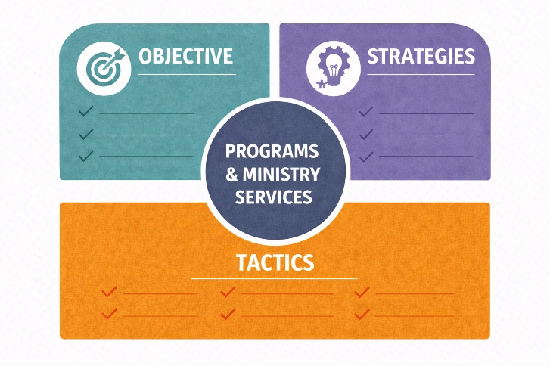
Whether local or global, each program offers opportunities to live out the Great Commission, build community, and reflect God’s love in practical, transformative ways.

Programs and Ministry Services Objective
(What will you achieve)
Develop and implement two comprehensive ministry programs over the next 12 months that expand community
impact to accelerate new disciple development by 30% through intentional outreach, service, and discipleship pathways.

Faith-Based Pre-K School Program Development Plan  - Strategy  - KPIs  - Target Audience  - Tactics  Faith-Based Pre-K School Program Development Plan Strategy  - KPIs  - Target Audience  - Tactics  (continued)  Faith-Based Pre-K School Program Development Plan  - Strategy  - KPIs  - Target Audience  - Tactics  (continued)  Faith-Based Pre-K School Program Development Plan  - Strategy  - KPIs  - Target Audience  - Tactics  (continued)  Faith-Based Pre-K School Program Development Plan  - Strategy  - KPIs  - Target Audience  - Tactics  (continued) |  | Strategy (How will you achieve it)  Develop a Christ-centered early childhood education program that nurtures young children's spiritual, emotional, social, and academic development while strengthening family engagement and community outreach.  This strategy emphasizes:  - Providing an excellent educational experience grounded in faith values  - Creating a safe, nurturing environment that reflects Christian love and learning  - Partnering with families to build spiritual and relational connections  - Positioning the pre-K as both an outreach and discipleship ministry  Key Performance Indicators (KPIs) (How will you measure it)  - Enrollment goal: 40 students in the first academic year  - Within 12 months, 20% of pre-K parents begin regularly attending the church with their child and/or become members  - 90% parent satisfaction rating (based on surveys)  - 80% of families engage in at least one church-sponsored event per semester  - Program achieves a self-sustaining operating budget by the end of year one  - Staff and volunteer retention rate of 90%  Target Audience (Who we are trying to reach)  - Families within the community with pre-K children  - Current faith community members and program users  Tactics (What will you do, step-by-step)  1. Planning and Foundation  - Form a Pre-K Development Committee of ministry leaders, educators, parents, and community advisors.  - Define program goals, curriculum standards, daily schedules, and spiritual formation components.  - Establish a budget and tuition model that balances accessibility with sustainability.  - Secure necessary state/local licensing, insurance, and compliance approvals for childcare and education facilities.  - Select a dedicated facility or classroom space, ensuring it meets safety, accessibility, and learning environment requirements.  - Responsibilities: TBD  - Timing: TBD  - Budget: TBD  2. Staffing and Training  - Hire a Program Director with early childhood education experience and a strong faith background.  - Recruit qualified teachers and aides with certifications and ministry-minded values.  - Provide training workshops on child development, faith integration, safety, and parent engagement.  - Create volunteer opportunities for church members (story time readers, snack helpers, maintenance support).  - Develop a teacher handbook and parent partnership guide.  - Responsibilities: TBD  - Timing: TBD  - Budget: TBD  3. Curriculum and Faith Integration  - Adopt a developmentally appropriate curriculum aligned with state learning standards and infused with biblical principles.  - Include daily devotionals, songs, and stories that teach values like kindness, gratitude, and respect.  - Celebrate holidays (Christmas, Easter, Thanksgiving) through art, storytelling, and service projects.  - Partner with children’s ministry leaders to ensure consistency between church and school faith formation.  - Host a “Chapel Time” each week or daily for prayer, music, and simple Bible lessons.  - Responsibilities: TBD  - Timing: TBD  - Budget: TBD  4. Marketing and Enrollment  - Create a branding identity for the pre-K (name, logo, tagline) that reflects warmth, excellence, and faith.  - Develop promotional materials, brochures, banners, website pages, social media presence, and enrollment forms.  - Host open houses and preview days for parents to tour facilities and meet teachers.  - Offer early enrollment incentives (discounts, waived registration fees).  - Partner with local churches, daycare centers, and family networks to share referrals.  - Highlight testimonials and ministry stories through videos, newsletters, and social media campaigns.  - Responsibilities: TBD  - Timing: TBD  - Budget: TBD  5. Awareness and Volunteerism  - Offer parent resource workshops (e.g., child development, Christian parenting, managing screen time).  - Encourage parents to volunteer in classrooms, chapel time, or seasonal celebrations.  - Host seasonal events like a Fall Festival, Christmas Program, and Spring Picnic to connect families with church life.  - Collaborate with local nonprofits (e.g., food pantries, shelters) for family service projects that model community compassion.  - Responsibilities: TBD  - Timing: TBD  - Budget: TBD  6. Communications  - Include pre-K families in the church communication loop, newsletters, invitations to worship, and family ministries.  - Feature pre-K updates and student highlights during Sunday services to reinforce connection with the congregation.  - Develop a “Church Partner Program” where members can sponsor tuition scholarships for families in need.  - Create a bridge to other ministry programs such as Parents’ Night Out, Vacation Bible School, or Children’s Church.  - Responsibilities: TBD  - Timing: TBD  - Budget: TBD  7. Evaluation and Growth  - Conduct quarterly parent surveys to assess satisfaction, feedback, and program impact.  - Review staff performance and professional development needs biannually.  - Measure outcomes such as school readiness, spiritual understanding, and family engagement.  - Adjust curriculum, schedule, and communication methods based on insights.  - Plan for Phase 2 growth, such as adding a second classroom or expanding age groups, once year-one goals are met.  - Responsibilities: TBD  - Timing: TBD  - Budget: TBD  8. Total Budget for all Pre-K School Development Tactics
Young Adult Outreach Program Development Plan  - Strategy  - KPIs  - Target Audience  - Tactics  Young Adult Outreach Program Development Plan  - Strategy  - KPIs  - Target Audience  - Tactics  (continued)  Young Adult Outreach Program Development Plan  - Strategy  - KPIs  - Target Audience  - Tactics  (continued) |  | Strategy (How will you achieve it)  Reach more young adults (20s -30s) by aligning community, content, and channels around real-life relevance and measurable outcomes, and build a sustainable, growing young adult ministry that engages with the mission and ministry of the church.  Key Performance Indicators (KPIs) (How will you measure it)  - Increase young adult attendance by 25% in 12 months.  - Launch 3 active small groups with 8–12 participants each.  - Achieve a 33% engagement rate in weekly digital content.  Target Audience (Who we are trying to reach)  Young adults aren't one group, and each group needs different messaging and entry points.  Segment them:  - Explorers – Curious, not committed  - Returners – Grew up in church, now re-engaging  - Committed – Seeking deeper growth  - Disconnected – Skeptical but open to relationships  Tactics (What will you do, step-by-step)  1. Training Leaders  Train or hire leaders who can address real-life struggles (anxiety, purpose, relationships), encourage honest dialogue and questions, and replace polish with relatability and transparency  - Responsibilities: TBD  - Timing: TBD  - Budget: TBD  2. Communications  Communicate to the target audience using media and content relevant to their needs:  - Invest in short-form video reels (TikTok, YouTube, Instagram, Facebook)  - Share practical, life-relevant content  - Maintain consistent posting cadence  - Responsibilities: TBD  - Timing: TBD  - Budget: TBD  3. Create Service Opportunities  Connect faith to purpose and impact by providing hands-on service opportunities that can tie teaching to action steps. Consider:  - Food bank distribution or mobile pantry teams  - Neighborhood clean-up and beautification projects  - Homeless outreach (meal kits, hygiene packs, care bags)  - Partnering with local shelters or crisis centers  - Tutoring or reading programs for elementary students  - Mentoring teens (especially at-risk youth)  - Supporting special-needs programs or adaptive learning groups  - Career guidance for high school/college students  - Social media/content creation for nonprofits  - Website design or tech support for ministries  - Resume workshops or job coaching  - Financial literacy or budgeting classes  - Refugee or immigrant support (housing, job help, ESL tutoring)  - Environmental stewardship (tree planting, sustainability projects)  - Crisis pregnancy or foster care support  - International service trips (construction, education, medical aid)  - Disaster relief missions  - Partnering with global churches or ministries  - Responsibilities: TBD  - Timing: TBD  - Budget: TBD  4. Channel Alignment  Align channels and messaging to ensure consistency across:  - Pulpit messaging  - Social media content  - Website and first-time visitor experience  - Small group discussions  - Responsibilities: TBD  - Timing: TBD  - Budget: TBD  5. Total Budget for all Young Adult Outreach Program Tactics
 | More Ideas for Programs and Ministry Services

Use these ideas to help guide and expand your development of objectives, strategies, and tactics.

Missionaries  and Relief Organizations  Missionaries  and Relief Organizations  (continued) | Global Missionary and Relief Support: Supporting missionaries and relief organizations is one of the most powerful ways ministries extend their reach beyond their walls.  Provide financial, prayer, and logistical support to missionaries serving both locally and internationally. Regularly highlight their stories through worship services, newsletters, and videos so the congregation can see the impact of their giving and prayers. Encourage “adopt-a-missionary” partnerships where individuals, families, or small groups commit to ongoing support.  International Ministry Organization Examples  World Vision International: An evangelical Christian NGO focused on humanitarian and disaster relief, with a significant emphasis on child sponsorship and programs to empower communities in over 90 countries. www.worldvision.org  Samaritan's Purse: A Christian charity that provides critical needs like food, water, shelter, and medicine to those in crisis and conflict zones in more than 100 countries. www.samaritanspurse.org  Compassion International: This organization works exclusively through local churches to support children in over 25 countries across Africa, Asia, and Latin America through one-on-one sponsorship programs that foster development. www.compassioninternational.org  MAP International: A global health and development organization that provides medicine and health supplies to communities in need. www.mapinternational.org  World Relief: An organization that provides disaster relief, refugee services, and community development programs, often working with government grants. www.worldrelief.org  Heifer Project International: Founded by a Midwestern farmer, Heifer promotes sustainable agriculture as a lasting way to alleviate poverty worldwide. Heifer brings individual freedom to families living in extreme poverty by giving them the means to produce food for their families and to sell it at market. www.heifer.org  Denomination-Based Relief Organizations: If your church is affiliated with a denomination, it may offer its own international relief agencies.
Community Ministry Partners  Community Ministry Partners  (continued) | Partnering with established community organizations allows your ministry to multiply its impact through collaboration.  Work alongside local and national ministries that share your values by providing workforce, resources, or facilities to support their missions.  For example, join Habitat for Humanity build projects, sponsor meals for Salvation Army shelters, or volunteer at pregnancy care centers.  Community Ministry Partner Examples  Habitat for Humanity: Habitat for Humanity International is explicitly a Christian organization whose ministry aims to eliminate substandard housing and homelessness.  Salvation Army: The Salvation Army has more than 7,500 centers across the U.S., serving those who are most in need: the hungry, the outcast, the lonely, and the homeless.  Feeding America: One in eight Americans struggles with hunger every day, Feeding America says. Through its network of food banks, Feeding America works to address hunger and food insecurity in the U.S.  CaringBridge.org: CaringBridge is a platform that lets people experiencing a health crisis connect with the world for help. It leverages the American community to help some of the neediest citizens and inspires one of its most powerful values: compassion.  Local Relief Organizations: Look for local relief organizations within your community, such as pregnancy centers, homeless shelters, and feeding centers.
Church School  Church School (continued)  Church School (continued) | A church school, whether a preschool, K–12 academy, or weekday enrichment program, can be one of the most effective long-term ways to extend a ministry’s reach and build enduring relationships with families both inside and outside the congregation.  It combines education, faith formation, and community service into a single, relational platform.  Starting a church school can powerfully extend a church’s mission, but it also introduces significant operational, financial, and cultural complexity. The most successful church schools think strategically before launching.  Issues to Carefully Evaluate Before Starting a Church School:  1. Mission Alignment & Purpose Clarity  Before anything else, define why the school should exist.  - Is the goal discipleship, academic excellence, community outreach, or all three?  - How will the school reinforce the church’s mission and not compete with it?  - Will it primarily serve church families, or the broader community?  Key Insight: A school without a clearly defined purpose often drifts and struggles with identity, enrollment, and leadership decisions.  2. Financial Sustainability (Beyond Start-Up)  Many churches underestimate the true cost of operating a school.  - Start-up costs: facilities, licensing, curriculum, staffing  - Ongoing costs: salaries, maintenance, insurance, technology  - Revenue model: tuition vs. subsidies vs. fundraising  Critical Questions:  - Can the school break even, or will the church need to subsidize it long-term?  - What enrollment is required to sustain operations?  Reality Check: Even well-run church schools often operate on tight margins. A multi-year financial model is essential.  3. Leadership & Governance Structure: Running a school requires different expertise than running a church.  - Who is ultimately responsible: pastor, board, or school administrator?  - Will there be a separate school board?  - Do you have access to experienced educational leadership (e.g., a qualified principal)?  Best Practice: Clearly define decision-making authority to avoid conflict between church leadership and school administration.  4. Legal, Accreditation & Compliance Requirements: Church schools must navigate a range of state and local regulations, which vary by location.  - Licensing requirements  - Teacher qualifications  - Health, safety, and facility codes  - Accreditation options (which impact credibility and college readiness)  Bottom Line: Legal missteps can create serious risk. Consulting an education attorney or consultant early is wise.  5. Community Demand & Enrollment Viability  - A great idea only works if there is sustained demand.  - Is there a need for a faith-based school in your area?  - What age groups are most in demand (preschool, elementary, high school)?  - Who are your competitors (public, charter, private, homeschool networks)?  Validation steps:  - Survey church members and the broader community.  - Assess local demographics and population trends.  - Test interest before building infrastructure.  Culture & Expectations: This is often overlooked, but critical.  - Are parents expecting academic rigor, spiritual formation, or both?  - How will discipline, curriculum, and worldview be handled?  - Will the school create unity or tension within the congregation?
Member Training and Education  Member Training and Education  (continued)  Member Training and Education  Member Training and Education  (continued) | Internships and Vocational Residency: Develop internship or ministry residency programs for young adults exploring vocational ministry or service leadership. Offer opportunities to serve in preaching, worship, youth ministry, missions, or administration.  Mentor residents to grow both spiritually and professionally as future leaders of faith.  Job Skills or Financial Literacy Workshops: Help church members improve their livelihoods and learn stewardship principles.  Youth Leadership Training: Equip young believers to lead and serve in missions, worship, and community service.  Mentoring and Tutoring: Pair congregation members with students or young adults for guidance and discipleship.
Giving and Sharing | Christmas Gift Boxes (Operation Christmas Child, Local Family Outreach): Collect and distribute Christmas boxes filled with gifts, school supplies, and devotionals for children and families in need. Partner with organizations such as Samaritan’s Purse or create a local initiative that reflects Christ’s generosity during the holidays. Include prayer cards and messages of hope in each box.  Backpacks for Kids: Provide backpacks filled with school supplies, snacks, and notes of encouragement for students in need. Partner with local schools or family resource centers to identify recipients. Include age-appropriate devotionals or Bible verses to remind students of God’s love and their worth.
Community Nutrition  and Wellbeing  Community Nutrition  and Wellbeing  (continued) | Food Truck Ministry: A church-operated food truck ministry blends practical compassion with relational outreach. It takes the church’s mission directly into the streets, feeding bodies, listening to hearts, and planting seeds of faith through consistent presence and service.  Thanksgiving and Christmas Meals: Organize community-wide Thanksgiving and Christmas dinners or deliver meals to homebound neighbors. Invite congregation members to serve, cook, or donate food. Transform the event into an opportunity for fellowship and gratitude, celebrating God’s provision together.  Community Food Drive and Food Pantry: Collect and distribute food to individuals and families facing hunger or hardship. Partner with local grocers, schools, and civic groups to sustain regular donations. Offer prayer and spiritual resources along with food assistance to meet both physical and spiritual needs.  Thrift Shop and Clothing Drive: A church-operated thrift shop can be an exceptionally effective and sustainable form of ministry and community outreach. It meets practical needs and creates spiritual opportunities, blending compassion, stewardship, and connection in ways that align with a church’s mission. It provides dignity to those in need, fosters relationships, empowers volunteers, and projects the church’s values into the heart of the community.
Community Events, Festivals, and Fairs | Family Events: Host family-friendly events such as fall festivals, outdoor concerts, movie nights, or block parties where faith is shared through hospitality and presence, not pressure. Use these gatherings to connect with neighbors, offer prayer stations, distribute ministry materials, and build relationships in a relaxed, welcoming environment.
Health  and Wellness  Health  and Wellness  (continued) | Community Health Screenings and Blood Drives: Partner with medical professionals and organizations such as the Red Cross to host blood drives, health screenings, and wellness fairs. Position your ministry as a source of healing and care, reflecting Christ’s compassionate care for the whole person.  Fitness Center, Organized Sports, and Wellness Programs:  Health and recreation ministries can reach individuals who might not connect through traditional worship to promote stewardship of the body, foster outreach, and model holistic discipleship- body, mind, and spirit. Offer faith-based fitness classes, walking groups, yoga, Zumba, or sports leagues that integrate prayer, scripture, and fellowship. Encourage members to invite neighbors, co-workers, and friends. Larger ministries could consider building large fitness centers with aquatics, basketball, and other sports courts, exercise rooms, and specialty rooms for ballet and dance practice.
Church Fellowship Events | Sunday Coffee and Fellowship: Create informal spaces before and after worship to deepen relationships. Encourage ministry leaders to mingle, listen, and engage in conversations that nurture belonging. Use these moments for discipleship invitations, small group promotion, or community updates to build community bonds, foster authentic connection, and help visitors transition from attendees to participants.  Church Picnics and Potluck Dinners: Regular, annual, or seasonal picnics and potluck dinners foster fellowship and community connection. Use these events as opportunities to reach out to the broader community, local families, and ministry partners. Include music, testimonies, games, and prayer time to celebrate unity in Christ.  Game Nights: Game nights offer members and their families a chance to connect on a personal level in a fun, engaging way outside a worship setting. They help to promote understanding of different personalities and improve interpersonal relationships.
Church Member Services  Church Member Services  (continued) | Bookstore and Giftshop: Operate a ministry bookstore offering Bibles, devotionals, study guides, and Christian literature to encourage faith development and provide resources for spiritual growth, while supporting ministry goals. Include inspirational gifts, fair-trade items, or materials supporting mission projects. Use sales proceeds to fund outreach or discipleship programs.  Library: Establish a church library or digital resource center where members can borrow books, videos, or study materials. Feature sections on theology, marriage, parenting, and spiritual growth. Encourage small groups to use the library as a hub for learning and discussion to support discipleship, lifelong learning, and access to faith-enriching resources.  Performing Arts Center: A performing arts center allows a large church to move from a place of worship to a cultural, spiritual, and community beacon. It promotes transformational advantages, both spiritually and strategically, and can expand the church’s reach and deepen community relationships. It amplifies outreach, fosters creativity, develops talent, and strengthens the church’s presence in the community.  Café: Create a welcoming café space where members and visitors can connect over coffee or meals. Use the café for small group gatherings, prayer meetings, or community drop-ins. Offer Christian music, devotionals, and ministry updates to maintain a faith-centered atmosphere.
Volunteerism | Hands-on Service: Empower members to take ownership of their church through participation in worship, sound, AV, other creative ministries, and fix-up/clean-up days.  Decorating for the Church Seasons: Involve members in decorating the church during Advent, Christmas, Easter, and other occasions.  Parents’ Night Out: Offer childcare nights that give parents rest and adult fellowship.  Senior Ministry: Visit care facilities, offer transportation, and create fellowship opportunities for aging members.

Based on these examples and your own analysis of your needs, write your own Programs and Ministry Services objective, strategies, and tactics using these forms or the online forms found at www.MinistryMarketingPlan.com.

Question 40 | Your Objective for Programs and Ministry Services
Question 41 | Your Strategies for Programs and Ministry Services
Question 42 | Your KPIs for Programs and Ministry Services
Question 43 | Your Target Audience for Programs and Ministry Services
Question 44 | Your Tactics for Programs and Ministry Services
 |  | Ministry Delivery Channels  Examples

Ministry delivery channels are the pathways through which your church brings God’s Word, grace, and community into people’s lives. They represent every gathering, outreach, and service opportunity that connects your mission to the people you serve, from weekly worship to global missions. They become bridges that | 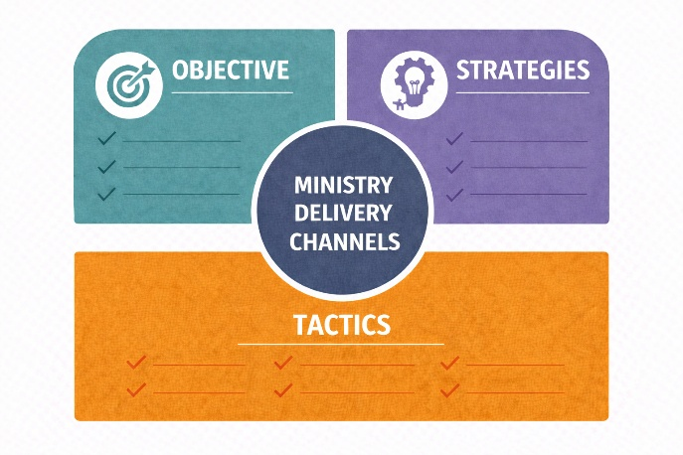
reach new hearts, nurture discipleship, and grow the presence of Christ’s church in the world.

Ministry Delivery Channels Objective
(What will you achieve)
Redesign and improve ministry delivery channels to increase average weekly attendance (in-person and online) by 10 – 15% year-over-year and achieve a 30% growth in first-time visitors (with at least 30% returning for a second visit).

Visitor Follow-Up and Engagement Program  - Strategy  - KPIs  - Target Audience  - Tactics  Visitor Follow-Up and Engagement Program  - Strategy  - KPIs  - Target Audience  - Tactics  (continued)  Visitor Follow-Up and Engagement Program  Strategy  - KPIs  - Target Audience  - Tactics  (continued)  Visitor Follow-Up and Engagement Program  - Strategy  - KPIs  - Target Audience  - Tactics  (continued) |  | Strategy (How will you achieve it)  Develop a relational, multi-touch visitor follow-up and connection system that blends hospitality, communication, and personal ministry, ensuring every guest feels valued, cared for, and invited into deeper community and discipleship. This strategy emphasizes:  - Creating intentional, timely follow-up processes  - Using multiple communication channels (email, text, phone, mail, in-person)  - Engaging and tracking visitors relationally through ministry connection opportunities  Key Performance Indicators (KPIs) (How will you measure it)  - 30% increase in visitors who attend more than once  - 10% of visitors enrolled in small groups, classes, or ministry teams within three months  - 100% of new visitors receive a personal contact (call, email, or note) within 48 hours.  - 80% of new visitors receive at least one personal invitation to a ministry or event within 60 days.  Target Audience (Who we are trying to reach)  - Visitors and prospective faith community members  Tactics (What will you do, step-by-step)  1. Prepare for Welcome and Connection  - Train a Hospitality and Welcome Team to greet visitors warmly before and after services.  - Establish a clear visitor process flow, from arrival to follow-up, with designated roles (e.g., greeters, ushers, follow-up coordinators).  - Provide Visitor Connection Cards (physical and digital) for collecting contact info, prayer needs, and interests.  - Create a digital visitor landing page on the ministry website with an introduction video and “Plan Your Visit” form.  - Responsibilities: TBD  - Timing: TBD  - Budget: TBD  2. Initial Follow-Up (Within 48 Hours)  - Assign a Connection Coordinator or Welcome Ministry Leader to oversee timely contact.  - Send a personalized thank-you email or text within 24–48 hours, expressing gratitude for their visit and offering to answer questions.  - Include links to worship replay videos, the church calendar, or upcoming newcomer events.  - Within 72 hours, send a handwritten card or note from the pastor or a ministry volunteer expressing appreciation and extending an invitation to return.  - For visitors who shared prayer requests, ensure someone calls or messages them to pray personally and provide support.  - Responsibilities: TBD  - Timing: TBD  - Budget: TBD  3. Second Touchpoint (Within 2 Weeks)  - Send a “Get to Know You” email introducing ministry opportunities (children’s ministry, small groups, outreach teams).  - Add visitors to the monthly newsletter or e-blast featuring upcoming community events.  - Follow up with a personal phone call from a pastor, ministry leader, or trained volunteer to thank them again and offer to meet for coffee or prayer.  - Invite the visitor to a newcomer gathering or “Meet the Pastor” session scheduled monthly.  - Responsibilities: TBD  - Timing: TBD  - Budget: TBD  4. Third Touchpoint (Within 30–60 Days)  - Encourage participation in a Foundations of Faith or Membership Class.  - Provide an invitation to volunteer in simple, low-commitment service opportunities (e.g., community events, meal prep, ushering).  - Match new families with mentors or ministry partners.  - Use a Customer Relationship Management (CRM) system or database to track progress, attendance, and involvement milestones. (e.g., Tithe.ly) offers comprehensive CRM tools.  - Responsibilities: TBD  - Timing: TBD  - Budget: TBD  5. Integration and Long-Term Engagement  - Celebrate new members and participants publicly (with consent) during worship or in newsletters.  - Share testimonies of transformation from new attendees who have become active members.  - Send 6-month and 12-month follow-up surveys to measure connection satisfaction and spiritual growth.  - Encourage ongoing involvement through invitations to small groups, mission trips, or discipleship programs.  - Responsibilities: TBD  - Timing: TBD  - Budget: TBD  6. Total Budget: All Visitor Follow-up and Engagement Tactics
 | More Ideas for Ministry Delivery Channels

Use these ideas to help guide and expand your development of objectives, strategies, and tactics.

Worship Services  Worship Services  (continued) | Worship is the heart of every faith community where people encounter God’s presence, find renewal, and unite as the Body of Christ. Offering diverse worship formats and times allows your ministry to meet people where they are: spiritually, culturally, and personally.  Sunday Morning Worship: Worship is the cornerstone of congregational life. It’s a time of praise, preaching, and fellowship that grounds the week in God’s Word. Use this service to celebrate community, share testimonies, and invite all to experience spiritual renewal.  Sunday Evening Worship: Offers a more reflective or informal setting, ideal for prayer, contemporary music, or smaller group connection. It provides a second touchpoint for members seeking quiet reflection or who can’t attend morning worship.  Weekday Worship: Weekday services sustain spiritual growth between Sundays. They may feature teaching series, communion, or worship-and-prayer gatherings that strengthen discipleship.  Saturday Worship: Ideal for individuals and families with Sunday commitments or non-traditional schedules.  This option also reaches seekers who are exploring faith outside the traditional Sunday pattern.  Classical, Contemporary, and Blended Styles: Each worship style attracts a different audience. Classical services often feature traditional liturgy, hymns, and choir-led music, while contemporary worship uses praise bands and multimedia to reach younger or newer believers. Blended services can combine the best aspects of each worship style. Both express timeless truths through culturally resonant forms.  Youth Worship: Youth services combine contemporary music with upbeat and alternative worship styles to create safe, energizing spaces for young believers to lead and grow in faith.  Special Needs-Focused Worship: Special needs worship services extend inclusion and a sense of belonging to all God’s children and young adults with special needs through adaptive music, sensory-friendly settings, pastoral care, and other specialized instructional methods.
Worship Space  and Facilities | Your physical environment reflects your ministry’s heart.  Worship services unify believers, invite seekers, and establish a rhythm of praise and discipleship that anchors all ministry activities.  Design worship spaces and education areas that foster community, learning, and accessibility. Use signage, lighting, and art to communicate welcome and reverence, ensuring every corner of your building, inside and out, supports connection, ministry, and mission.  If your worship spaces are nearing capacity during services, consider adding additional service times. If you reach capacity, consider a worship space needs assessment that could conclude that a new building or a renovation campaign is needed.
Pastoral Care  Pastoral Care  (continued) | Pastoral care extends the church’s compassion to those facing illness, loss, or life challenges. Through presence, prayer, and spiritual guidance, pastoral care ensures that no member walks alone. Pastoral care reflects Christ’s compassion and deepens community bonds through presence and prayer.  Hospital and Nursing Facilities: Pastors and care teams visit members in hospitals or long-term care facilities, offering prayer, communion, and comfort. These visits are under God’s care.  End-of-Life and Hospice Care: Provide spiritual support to individuals and families during transition and grief. End-of-life ministry emphasizes hope, eternal life, and peace in Christ.  In-Home Visitations: Offer in-home visits that can include communion and prayer for individuals unable to attend church in person.  Confessional and Counseling: Create safe, confidential spaces where individuals can confess burdens, seek forgiveness, and receive pastoral guidance. Offer biblical counseling, emphasizing grace and restoration.  Prayer and Counseling: Prayer is the heartbeat of ministry, building spiritual resilience, healing, and unity across the church body. Offer regular prayer meetings, intercessory teams, and counseling ministries that respond to members’ spiritual and emotional needs. Encourage both digital and in-person prayer requests to create a culture of ongoing intercession.
Visitors and New Members | Follow-up with Church Visitors: Establish a systematic follow-up process for church visitors, including a phone call, an email, a welcome bag, an invitation to a pastor’s luncheon, information on inquirers' classes, and a personal home visit.  Inquirers’ Classes / Introduction to the Faith: Provide classes for seekers exploring Christianity or church membership, helping them grow from curiosity to commitment and supporting their journey into faith and community. Cover foundational beliefs, practices, and spiritual disciplines in a welcoming, nonjudgmental environment. Include opportunities for dialogue, mentorship, and personal testimony.
Music Ministry  Music Ministry (continued) | Music is both worship and outreach, a universal language that draws hearts toward God. A thriving music ministry unites people of all ages and backgrounds through praise and performance.  Adult Choirs: Inspire worship with choral excellence, blending tradition with heartfelt devotion.  Choirs also foster fellowship and spiritual growth among members.  Children’s Music: Children’s choirs nurture faith formation through song and creativity. Music can teach children scripture, teamwork, and the joy of praise. Performances can also draw parents to the church.  Contemporary Praise Band: Praise bands can play a key role in supporting contemporary worship experiences that engage younger generations and seekers. Across all demographics, praise bands can become locally recognized and reach audiences through performances beyond the church walls.  Classical Orchestra: A classical orchestra can lead more formal worship styles that engage audiences across all demographics. Orchestras can also collaborate in concerts or local performances to reach beyond church walls.  Guest Performances, Pageants, and Concerts: Special music events, such as Christmas or Easter services, or community concerts, open doors for outreach and evangelism. Invite local and regional accomplished artists, orchestras, schools, and choirs to collaborate and perform.  Music School: Because music touches the soul, transcends barriers, and brings worship to life for believers and seekers alike, offer voice and instrument lessons as a ministry outreach. Integrate prayer, scripture, and mentorship to help students develop both musical skill and spiritual growth.
Faith Formation  Faith Formation (continued)  Faith Formation (continued) | Children’s Ministries: Children’s ministries sow the seeds of lifelong faith. They offer safe, joyful spaces where children learn about God’s love and experience the Gospel in action.  Confirmation and Leadership Roles: Equip youth for mature discipleship through confirmation, leadership training, and peer mentoring.  Nursery, Sunday School, and Bible Lessons: Provide nurturing care and age-appropriate teaching that introduces foundational faith concepts.  Use creative storytelling, crafts, and music to bring scripture to life.  Vacation Bible School (VBS), Preschool, and School Programs: VBS and educational ministries reach families beyond regular attendees. Each becomes an evangelistic opportunity to engage new households and strengthen community connections.  Youth Ministries: Shape future disciples and leaders. They provide safe spaces for growth, service, and belonging, blending faith, fun, and purpose. Camps, youth mission trips, and service projects teach sacrifice, teamwork, and the joy of serving others. Mission trips especially help youth see their role in global Christianity.  Adult Ministries: Adult ministries help believers grow deeper in faith through learning, service, and spiritual support.  Bible Studies, Small Groups, and Spiritual Formation: Provide ongoing opportunities for scriptural study, prayer, and accountability. Small groups foster relational discipleship, which is a vital bridge between Sunday worship and daily living.  Lay Leadership Development: Train lay leaders, ministry coordinators, and small group facilitators to serve confidently and biblically in the church.  Theology and Guest Lecture Series: Encourage a deeper understanding of faith and culture through lectures and workshops. Invite theologians, missionaries, or Christian authors to inspire and motivate members.  Retreats, Pilgrimages, and Mission Trips: Provide transformative experiences where faith is renewed through reflection, travel, and service. They can build mature disciples, strengthen families, and form leaders who carry the Gospel into their workplaces and communities.
Community Groups | Scouts: Allow scouting programs to use church facilities midweek to help connect with children and youth outside the church, beyond Sunday morning.  Campus Ministries: Support young adults on campus, in small groups, and in satellite worship experiences to connect them with your ministry.  Life Changes Support Ministries: Offers programs such as divorce recovery and grief counseling that meet the special, immediate needs of church members and community members with compassion and hope.  Caregiver Respite: Train members to offer caregivers, who are church and community members, respite from their daily and ongoing caregiver responsibilities.
Church Planting and Satellite Locations | Church planting and satellite campuses broaden the church’s presence in new communities, extend the ministry’s reach, decentralize leadership, and allow the Gospel to take root in diverse communities. Establish new congregations where there is spiritual need or population growth. Consider:  - Assisted living centers and nursing homes  - New towns and planned communities  - Campus settings

Based on these examples and your own analysis of your needs, write your own Ministry Delivery Channels objective, strategies, and tactics using these forms or the online forms found at www.MinistryMarketingPlan.com.
Question 45 | Your Objective for Ministry Delivery Channels
Question 46 | Your Strategies for Ministry Delivery Channels
Question 47 | Your KPIs for Ministry Delivery Channels
Question 48 | Your Target Audience for Ministry Delivery Channels
Question 49 | Your tactics for Ministry Delivery Channels
Section IV | Executive Summary

Executive Summary Background  An executive summary is an important part of a ministry marketing plan because it provides a concise, high-level overview of the plan’s most critical elements: objectives, strategies, tactics, target audiences, expected results (KPIs), and budgets. It helps | 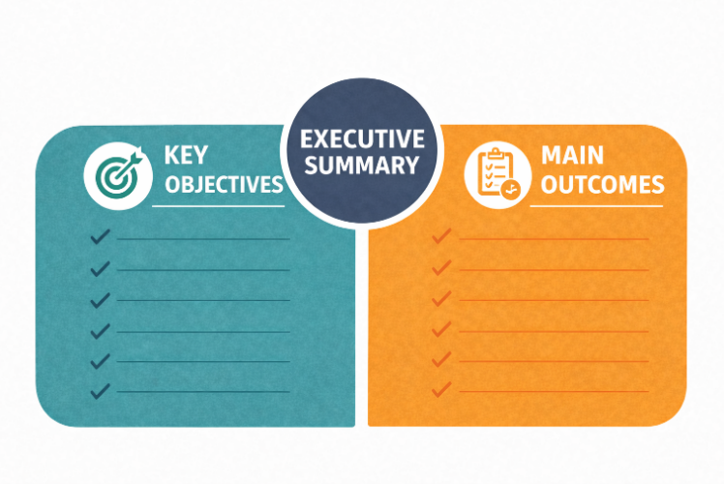
the faith ministry’s leaders and members quickly understand the plan’s purpose, priorities, and impact without reading the full document.

In Short, It Answers
What are we doing, why, for whom, what results do we expect, and at what cost?

This makes it a vital tool for gaining alignment, approval, and support.

Question 50 |
Key Objectives, Strategies, and Tactics
- Recap the main objectives of the ministry marketing plan
- Reiterate the strategies and how they align with the ministry’s objectives
- Highlight core target supporters, positioning, and key tactics
Question 51 | Strategic Focus Areas
Briefly outline the primary strategic priorities in each of the four areas of improvement. Emphasize how these engagement focus areas will drive growth and improvement.

Faith Member & Community Awareness:

Stewardship & Giving:

Programs & Ministry Services:

Ministry Delivery Channels:

Question 52 |
Main Outcomes
Summarize the anticipated results to be achieved from the implementation of the strategies and tactics.
Reference any success metrics or KPIs introduced earlier in the plan.

Question 53 | Summarize the KPIs and Budgets for Each Objective

Objectives |  | KPIs | Budgets
Faith Member & Community Awareness:

Stewardship & Giving:

Programs & Ministry Services:

Ministry Delivery Channels:

Question 54 |
Plan for Execution and Review
- Mention who is responsible for implementing the plan.
- Identify timelines, checkpoints, or review processes to track progress.
- Include how adjustments will be made if objectives are not met
Question 55 |
Closing Statement or Call
to Action
- End with a motivating statement that reinforces the faith-based organization’s commitment to execution.
- If the plan is being presented for approval, include a statement requesting feedback, endorsement, or resources needed.

Closing Statement Example
“With a clear strategy, measurable goals, and a focused execution plan, this ministry marketing roadmap empowers us to amplify our impact by building membership and Average Worship Attendance (AWA), increasing giving, expanding programs to members and the community, strengthening our association with faith-focused organizations in the community, and forging stronger internal relationships with ministry team members and volunteers.”

Section V | Appendix

Include here additional comments, acknowledgments, or names of contributors to the plan, references for budgets, detailed calendars, or research.

Addendum

Member Survey Tool

Instructions  This survey should be completed anonymously by all faith community members aged 16 or older, planning team members, staff, and non-members connected to the church before the planning team completes the SWOT Analysis and ministry marketing plan. Feel free to edit or add questions to fit your faith ministry's unique needs. To simplify data collection and analysis, transfer the survey form to an inexpensive online survey service, such as SurveyMonkey or Jotform. Deliver the survey | 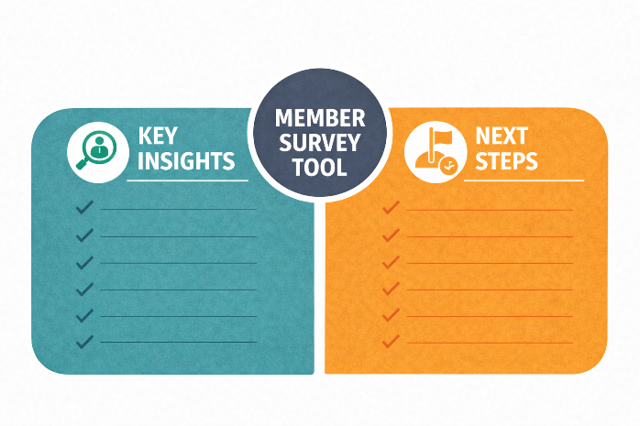
 | 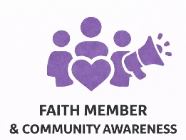 | 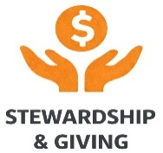
 | 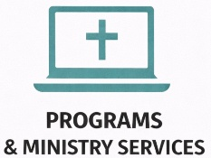 | 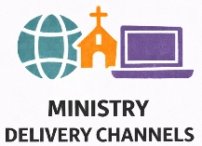
to members via email and allow only one submission per member. Make paper surveys available for members who do not use email or the internet. Ideally, a professional with ministry-minded values outside your faith community should analyze and interpret the survey results.

Please circle the number that best represents your profile.

The following questions ask for demographic information (age, length of membership at the church, role, etc.). These questions will not compromise the anonymity of your answers. They will help church leadership better understand the data across subgroups.

General Survey Questions

Length of Involvement

I have been attending this church for: | X for Your Answer
Less than two years
Between 2-4 years
Between 5-10 years
More than 10 years

Age Group

I am between the ages of: | X for Your Answer
16-25
26-40
41-55
56-69
70+

Church Position

My position with the church is: | X for Your Answer
Leader / involved in ministry
Regular worship attender
Non-regular worship attender
Do not attend worship, but have connections to the church

Family Structure

I am: | X for Your Answer
Married, no children under 18
Married, children under 1
Single/widowed, no children under 18
Single/widowed, children under 1

+What is your zip code? ____________________

+Approximately how many miles do you travel to church each
time you attend? ___________________________

Faith Member and Community Awareness
Survey Questions

Faith Member and Community Awareness helps reach your congregation and community by sharing stories of faith, service, transformation, and inspiring involvement.

**Please answer each of these questions by ranking 1 to 5.
One equals poor, and five equals excellent.**

+Our pastors and leaders do an excellent job of communicating information, events, and expectations to members.
1 | 2 | 3 | 4 | 5 | No Opinion

Comments: ______________________________________________________ __________________________________________________________________

+This church makes effective use of various communication methods (bulletins, website, texts, newsletters, e-mail) to communicate news and information to members.
1 | 2 | 3 | 4 | 5 | No Opinion

Comments: ______________________________________________________ __________________________________________________________________

+Our church’s programs and ministries are effectively promoted in our community through paid advertising and free publicity.
1 | 2 | 3 | 4 | 5 | No Opinion

Comments: ______________________________________________________ __________________________________________________________________

+Our local community (or neighborhood) knows what our church stands for.
1 | 2 | 3 | 4 | 5 | No Opinion

Comments: ______________________________________________________ __________________________________________________________________

+Our church has a reputation as a “good citizen” in our community.
1 | 2 | 3 | 4 | 5 | No Opinion

Comments: ______________________________________________________ __________________________________________________________________

+Our church makes good use of signage, banners, exterior lighting, and other forms of building identification to visibly communicate our presence, vitality, and welcome to the community.
1 | 2 | 3 | 4 | 5 | No Opinion

Comments: ______________________________________________________ __________________________________________________________________

+Our church brand and logo accurately express our identity, purpose, and promise to members and the community at large.
1 | 2 | 3 | 4 | 5 | No Opinion

Comments: ______________________________________________________ __________________________________________________________________

+Our church mission and vision statements are memorable and accurately guide our actions, inspire our congregation, and communicate God’s purpose to the community.
1 | 2 | 3 | 4 | 5 | No Opinion

Comments: ______________________________________________________ __________________________________________________________________

+Our online calendar of events is regularly updated and easy to
access.
1 | 2 | 3 | 4 | 5 | No Opinion

Comments: ______________________________________________________ __________________________________________________________________

+We frequently use social media to inform members and the public about our church and its ministries.
1 | 2 | 3 | 4 | 5 | No Opinion

Comments: ______________________________________________________ __________________________________________________________________

+Our livestreaming of worship services is professionally produced, engaging, and interesting to watch.
1 | 2 | 3 | 4 | 5 | No Opinion

Comments: ______________________________________________________ __________________________________________________________________

+We make sure each visitor is welcomed to our church with a personal greeting and a personally presented welcome bag.
1 | 2 | 3 | 4 | 5 | No Opinion

Comments: ______________________________________________________ __________________________________________________________________

+Are there any other specific Faith Member and Community Awareness programs we should consider? (please list)

Comments:_________________________________________________________________________________________________________________________
__________________________________________________________________

Stewardship and Giving Survey Questions
Stewardship in ministry is more than raising funds. It’s discipleship in action. Faithful giving is an act of worship, gratitude, and partnership in God’s mission. Effective stewardship ministries cultivate generosity not through pressure, but through purpose, transparency, and spiritual invitation. Below are key areas of giving and how each can inspire faith, participation, and long-term sustainability for your ministry.

+I help support the church financially.
____Yes ____No

+I feel appreciated for the stewardship I provide the church.
1 | 2 | 3 | 4 | 5 | No Opinion

Comments: ______________________________________________________ __________________________________________________________________

+Our leaders appropriately discuss financial issues for the right amount of time (not too much, not too little).
1 | 2 | 3 | 4 | 5 | No Opinion

Comments: ______________________________________________________ __________________________________________________________________

+I am aware of our church’s financial condition through regularly posted updates.
1 | 2 | 3 | 4 | 5 | No Opinion

Comments: ______________________________________________________ __________________________________________________________________

+Our church provides information about giving to missions, special projects, and other designated needs.
1 | 2 | 3 | 4 | 5 | No Opinion

Comments: ______________________________________________________ __________________________________________________________________

+Our church regularly conducts special fundraising events such as silent auctions, raffles, and golf tournaments.
1 | 2 | 3 | 4 | 5 | No Opinion

Comments: ______________________________________________________ __________________________________________________________________

+Are there other specific Stewardship and Giving Programs we should consider? (please list).

Comments:_________________________________________________________________________________________________________________________
__________________________________________________________________
Programs and Ministry Services Survey Questions

Programs and ministry services are where faith becomes visible and where the Gospel moves from the sanctuary into the streets, neighborhoods, and nations. These initiatives represent the heart of the church’s mission: to love God, serve others, and make disciples of all nations. Whether local or global, each program offers opportunities to live out the Great Commission, build community, and reflect God’s love in practical, transformative ways.

+Our church actively supports missions, both locally and globally, and encourages members to do the same.
1 | 2 | 3 | 4 | 5 | No Opinion

Comments: ______________________________________________________ __________________________________________________________________

+Our church effectively meets the needs of single adults with Christian education and special activities.
1 | 2 | 3 | 4 | 5 | No Opinion

Comments: ______________________________________________________ __________________________________________________________________

+Our church provides excellent Christian education for all adults.
1 | 2 | 3 | 4 | 5 | No Opinion

Comments: ______________________________________________________ __________________________________________________________________

+Our church effectively meets the needs of senior citizens with Christian education and special activities.
1 | 2 | 3 | 4 | 5 | No Opinion

Comments: ______________________________________________________ __________________________________________________________________

+My understanding of faith and ability to minister to others have grown through our church’s educational programs.
1 | 2 | 3 | 4 | 5 | No Opinion

Comments: ______________________________________________________ __________________________________________________________________

+Our church effectively meets children's needs and provides excellent Christian education and activities.
1 | 2 | 3 | 4 | 5 | No Opinion

Comments: ______________________________________________________ __________________________________________________________________

+Our church effectively meets the needs of youth and provides excellent Christian education and activities for them.
1 | 2 | 3 | 4 | 5 | No Opinion

Comments: ______________________________________________________ __________________________________________________________________

+This church encourages small group formation, and I am involved in a regular small group.
1 | 2 | 3 | 4 | 5 | No Opinion

Comments: ______________________________________________________ __________________________________________________________________

+I have received training from this church in some form of outreach, evangelism, or missions work.
1 | 2 | 3 | 4 | 5 | No Opinion

Comments: ______________________________________________________ __________________________________________________________________

+Our church does a good job of providing support beyond our walls to community members in need through programs such as meals, food, clothing drives, and backpacks for children.
1 | 2 | 3 | 4 | 5 | No Opinion

Comments: ______________________________________________________ __________________________________________________________________

+Our church emphasizes healthy living for members by offering programs such as fitness classes, lifestyle information, and health screenings.
1 | 2 | 3 | 4 | 5 | No Opinion

Comments: ______________________________________________________ __________________________________________________________________

+Our member festivals are open to the community and well attended.
1 | 2 | 3 | 4 | 5 | No Opinion

Comments: ______________________________________________________ __________________________________________________________________

+We regularly schedule events for members to encourage fellowship, such as picnics, potluck dinners, and Sunday coffee hour.
1 | 2 | 3 | 4 | 5 | No Opinion

Comments: ______________________________________________________ __________________________________________________________________

+Our church encourages volunteerism, such as church clean-up days and disaster relief teams.
1 | 2 | 3 | 4 | 5 | No Opinion

Comments: ______________________________________________________ __________________________________________________________________

+The church library is well stocked with Christian and faith-formation literature and is well managed.
1 | 2 | 3 | 4 |  | 5 | No Opinion

Comments: ______________________________________________________ __________________________________________________________________

+Are there other specific Programs and Ministry Services we should consider? (please list).

Comments:_________________________________________________________________________________________________________________________
__________________________________________________________________

Ministry Delivery Channels Survey Questions

Ministry delivery channels are the pathways through which your church brings God’s Word, grace, and community into people’s lives. They represent every gathering, outreach, and service opportunity that connects your mission to the people you serve, from weekly worship to global missions. When approached strategically and prayerfully, these channels don’t just serve existing members. They become bridges that reach new hearts, nurture discipleship, and grow the presence of Christ’s church in the world.

+Our worship services, times, and frequency effectively attract new people to our church.
1 | 2 | 3 | 4 | 5 | No Opinion

Comments: ______________________________________________________ __________________________________________________________________

+I feel inspired by our church’s worship services, and I can enthusiastically recommend our worship service to friends outside our church.
1 | 2 | 3 | 4 | 5 | No Opinion

Comments: ______________________________________________________
__________________________________________________________________

+The music ministry is effective and inspiring at all levels and lifts my spirit.
1 | 2 | 3 | 4 | 5 | No Opinion

Comments: ______________________________________________________ __________________________________________________________________

+Because of our location, newcomers can easily find our church.
1 | 2 | 3 | 4 | 5 | No Opinion

Comments: ______________________________________________________ __________________________________________________________________

+Our worship spaces and facilities are more than adequate to promote fellowship and special events.
1 | 2 | 3 | 4 | 5 | No Opinion

Comments: ______________________________________________________ __________________________________________________________________

+Our education and training facilities are more than adequate to meet the needs of all members.
1 | 2 | 3 | 4 | 5 | No Opinion

Comments: ______________________________________________________ __________________________________________________________________

+Our buildings and facilities are effective in supporting our children’s ministries.
1 | 2 | 3 | 4 | 5 | No Opinion

Comments: ______________________________________________________ __________________________________________________________________

+Our buildings and facilities are effective in supporting our youth ministries.
1 | 2 | 3 | 4 | 5 | No Opinion

Comments: ______________________________________________________ __________________________________________________________________
+Our buildings and facilities effectively support our young adult ministries.
1 | 2 | 3 | 4 | 5 | No Opinion

Comments: ______________________________________________________ __________________________________________________________________

+Our buildings and facilities are effective in supporting our senior ministries.
1 | 2 | 3 | 4 | 5 | No Opinion

Comments: ______________________________________________________ __________________________________________________________________

+If I need pastoral care, counseling, or advice, I know it is readily available through one of our church pastors.
1 | 2 | 3 | 4 | 5 | No Opinion

Comments: ______________________________________________________ __________________________________________________________________

+Our church has an effective follow-up program for those who have visited.
1 | 2 | 3 | 4 | 5 | No Opinion

Comments: ______________________________________________________ __________________________________________________________________

+We welcome community groups, such as Scouts, to use our facilities.
1 | 2 | 3 | 4 | 5 | No Opinion

Comments: ______________________________________________________ __________________________________________________________________

+Our church encourages mission trips and retreats for its members, both adults and youth.
1 | 2 | 3 | 4 | 5 | No Opinion

Comments: ______________________________________________________ __________________________________________________________________

+Are there any other specific Ministry Delivery Channels we should consider? (please list).

Comments:_________________________________________________________________________________________________________________________
__________________________________________________________________

Helpful Resources:
Faith and Culture Insights, Demographics

Several highly respected organizations and research centers produce reliable insights on Christian faith, culture, leadership, vocation, and generational belief trends in the U.S. (Ministries, seminaries, nonprofits, denominational leaders, and researchers use many of these to inform strategy, outreach, and discipleship planning.) | 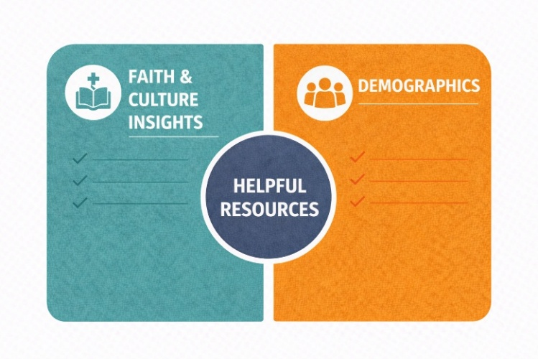
- Barna Group
What It Is: The Barna Group is a U.S.-based research and consulting organization that studies Christian faith, beliefs, culture, and generational trends, primarily within the evangelical and broader Christian community.
What Barna Group Does: Barna conducts surveys, studies, and trend analysis focused on how people think about:
- Faith and spirituality
- Church attendance and engagement
- Generational belief patterns (Gen Z, Millennials, Gen X, Boomers)
- Leadership, vocation, and calling
- Cultural influences on Christianity
- Ministry effectiveness and discipleship
Church leaders, pastors, nonprofits, seminaries, and faith-based organizations widely use their work to inform strategy, outreach, and leadership development.

What Barna Is Known For:
- Data-driven insights on faith and culture
- Generational research, especially on younger Christians
- Coining widely referenced concepts like “the Nones” (people with no religious affiliation)
- Annual reports and books that translate research into practical ministry implications
How Ministries Use Barna: Faith-based organizations often use Barna research to:
- Understand cultural and belief shifts
- Shape outreach and discipleship strategies
- Inform communications and messaging
- Guide leadership development and training
- Support planning and decision-making with credible data
Why Barna Is Influential:
Barna bridges the gap between academic research and practical ministry application. Their findings are frequently cited in sermons, leadership training, planning retreats, and Christian media.
www.barnagroup.com

- Pew Research Center, Religion & Public Life
What It Is: A widely cited, nonpartisan research organization that studies religion, public opinion, and social trends.
Strengths:
- Deep, longitudinal surveys on U.S. religious affiliation, belief, church attendance, and demographic shifts
- Data on interfaith trends, religious identity, and the social/political role of religion
- Freely accessible reports and datasets
Useful For: Understanding macro-level religious trends across generations and faith groups
https://www.pewresearch.org/religion/

- Fuller Youth Institute (FYI)
What it is: A research arm of Fuller Seminary focusing on youth, young adults, and intergenerational faith development.
Strengths:
- Studies on how faith develops across life stages
- Insights on youth ministry, discipleship, and spiritual leadership
- Practical resources and coaching for churches
Useful For: Generational discipleship strategy and understanding young believer trends
https://fulleryouthinstitute.org/

- Faith Communities Today (FACT)
What it is: A broad, ecumenical research project that surveys congregations and faith communities in the U.S.
Strengths:
- Data on congregational practices, worship participation, leadership, and engagement
- Trends on vitality, outreach, giving, and organizational health.
- Useful benchmarking data
Useful For: Ministry benchmarking and congregation-level planning.
https://faithcommunitiestoday.org/

- Lifeway Research
What it is: The research arm of Lifeway Christian Resources (Southern Baptist-affiliated, but widely used).
Strengths:
- Polls and studies on church attendance, beliefs, cultural trends, and ministry practices
- Generational, gender, and demographic insights
- Short reports with clear implications for ministry
Useful For: Practical, ministry-focused data and trend snapshots
https://research.lifeway.com/

- Hartford Institute for Religion Research
What it is: A research institute based at Hartford Seminary focused on congregational studies and religious trends
Strengths:
- Congregational research databases (ARD — American Congregational Research Database)
- Studies on leadership, diversity, and congregational life
Useful For: In-depth, academic yet accessible congregation-level data
https://hirr.hartsem.edu/

- Association of Religion Data Archives (ARDA)
What it is: A massive, searchable archive of religious data from diverse surveys and studies
Strengths:
- County-level and national-level data sets
- Historical trends and custom query tools
Useful for: Custom research, demographic mapping, and academic project support
https://www.thearda.com/

- American Bible Society, State of the Bible
What It Is: Annual reports focusing on Bible engagement in the U.S.
Strengths:
- Data on Bible reading habits, attitudes, and demographic patterns
- Yearly insights into cultural correlation with Scripture engagement
Useful For: Understanding Scripture engagement trends and spiritual formation patterns
https://www.americanbible.org/state-of-the-bible/

- Demographic Data
Churches that want to understand where their community’s growth is headed and desire deeper insights about people and family patterns by county, zip code, or a set distance from the church should look for reliable demographic data sources that are regularly updated, geographically precise, and easy to integrate into planning. Here are some sources (free and paid), what they offer, and when to use each:

Federal Government and Public Data Sources (Best Free Data)
U.S. Census Bureau
The gold standard for demographic data in the U.S.
Key Tools:
- data.census.gov, interactive search of population, age, race, income, education, household type, family structure, housing, etc.
- American Community Survey (ACS), detailed annual estimates at county, ZIP code (approximate via ZIP Code Tabulation Areas), and Census tract levels
- Decennial Census, every 10 years, full population count with complete demographic breakdowns
Good For:
- Congregational planning
- Community needs assessments
- Long-term strategic planning
https://www.census.gov

Community Profile Tools (Free and Easy to Use), Social Explorer
Interactive maps and easy export of key demographic variables
Good For:
- Quick visualizations
- Basic church planning reports
https://www.socialexplorer.com

PolicyMap
Map-based tool with layers for demographics, housing, income, jobs, and more
Good For:
- Site selection
- Community engagement planning
- Outreach targeting
https://www.policymap.com

SimplyAnalytics
Data visualization, radius/distance mapping, and easy demographic reports
Good For:
- Outreach strategy
- Grant proposals
- Ministry impact planning
https://simplyanalytics.com
(Often available through library access. Churches or ministry planners can get free access via public or university libraries.)

Demographic Analysis Worksheet
Understanding the People God Has Placed Around Us

Purpose:
This worksheet helps your ministry understand the people, families, and communities in your service area, so you can better align worship, programs, outreach, and communications with real needs and opportunities. Refer to Helpful Resources in the ADDENDUM. With input, AI can compile data from various sources and provide analysis and insights.

Ministry (Church) Name
Ministry Service Areas
States
Counties
Cities
ZIP Codes
Radius (miles) from Set Point (Address)
Data Sources Used
- Population Size and Growth
What it tells you: How many people live in your service area and whether the community is growing or shrinking.
Why it matters to churches: Growth may signal opportunity for expansion or new ministries. Decline may require consolidation or renewed outreach.
Ministry decisions influenced: Worship service times, facility expansion or downsizing, church planting, or satellite locations.

Total Population
Population Growth Trends
Median Age
Population Implications

- Age Distribution
What it tells you: The proportion of children, teens, young adults, families, and seniors.
Why it matters: Determines which ministries to prioritize.
Ministry decisions influenced: Nursery, Sunday school, youth group, senior groups, music style, worship format, and volunteer recruitment focus.

Children (0-12)
Youth (13-18)
Young Adults (19-34)
Adults (35-54)
Older Adults (55-74)
Seniors (75+)
Age Distribution Implications

- Household and Family Structure
What it tells you: Married couples, single parents, multigenerational households, and individuals living alone.
Why it matters: Different family types have different spiritual and practical needs.
Ministry decisions influenced: Parenting classes, marriage enrichment, divorce recovery, caregiver support, young adult ministries, and the number of families with children at home.
Why it matters: Children’s ministry often drives long-term church growth.
Ministry decisions influenced: Pre-K and preschool programs, Vacation Bible School, youth staffing and volunteers, and family-focused outreach.

Married Couples
Single Parents
Single, Not Married
Households with Children
Average Number of Children Per Household, Ages 0-12
Household and Family Structure Implications
- Income Levels
What it tells you: Household income distribution and economic diversity.
Why it matters: Helps churches plan stewardship strategies with sensitivity and realism.
Ministry decisions influenced: Inquirers’ classes, outreach tone and messaging, Alpha or seeker-friendly programs, giving expectations and messaging, scholarship or assistance programs, outreach, and benevolence ministries.
Median Income Per Household
Poverty Level
Income Levels
Implications

- Education Levels
What it tells you: The highest level of education attained in the community.
Why it matters: Education often correlates with learning preferences and engagement styles.
Ministry decisions influenced: Bible study formats, lecture vs. discussion-based learning, teaching depth, and communication style.

% Completing High School | % Completing College | % Completing College Post-Graduate
Education Levels Implications

- Housing Type and Stability
What it tells you: Renters vs. homeowners, length of residence, housing density.
Why it matters: Stability often influences long-term engagement and membership.
Ministry decisions influenced: newcomer follow-up strategy, small-group models, and outreach to apartment complexes.

% of Residents Homeowners
Average Number of Years of Home Ownership
% of Residents Renters
Housing Type and Stability Implications
- Ethnicity, Language, and Cultural Background
What it tells you: Cultural diversity and languages spoken at home.
Why it matters: Ensures hospitality and inclusion.
Ministry decisions influenced: Multilingual services, cultural celebrations, bilingual staff or volunteers, and community partnerships.

Ethnic Groups
Languages Spoken
Ethnicity, Language, and Cultural Background Implications

- Religious Affiliation and Faith Background
What it tells you: Percentage of people who are religiously affiliated, unaffiliated, or from other faith traditions.
Why it matters: Shapes evangelism, seeker engagement, and discipleship approach.

% of Population Affiliated with a Christian Church
% of Population Affiliated with Other Faith Traditions
% of Population Non-Affiliated
Implications for Affiliation and Faith Background
Top Demographic Insights

About The Author

RE (Bob) Casper brings together a lifelong commitment to faith with

decades of senior-level marketing and leadership experience. An active Anglican, he has served in church governance and strategic planning, lay leadership, fundraising, music, and as an organizer of missions, both internationally and locally.

After undergraduate and graduate studies in Marketing and Management at the University of Memphis, Casper built a distinguished career leading marketing and public relations initiatives for national companies and agencies across multiple markets. From 1997 until his retirement in 2016, he was a part-owner and Vice President/General Manager of ProAct Marketing Group in Kansas City, where he led account teams for major automotive brands, including General Motors and Toyota.

Following retirement, he founded Marketing Convergence Solutions, a consulting practice focused on helping businesses and nonprofits align revenue and marketing through structured planning. He is the author of The Marketing Planning Guidebook: A Practical How-To Guide on Bridging Silos to Create Rewarding Marketing Plans and continues to share insights through his blog posts at www.MarketingConvergenceSolutions.com.

He also served in the United States Air Force, working in Public Affairs with overseas and U.S. assignments.

Today, Casper’s life is shaped by a desire to share the practical wisdom gained through a rich professional journey serving ministries and organizations seeking clarity, alignment, and lasting impact.

www.convergencestrategies.com
www.marketingconvergencesolutions.com
MinistryMarkeringPlan.com
info@convergencestrategies.com



